

Term Project

Team # 5

Prof. Patrick Miller

Table of Contents

System Vision Document

Interview

Interview Results

Employee Survey

Employee Survey

Part 1 (results)

Part 2 of Survey (results)

Part 3 of Survey (results)

Feasibility Issues

Project Estimates

Risk Matrix

Domain Model Class Diagram

Network Diagram

Final Cut Design Class Diagram

Relational Database

List of Use Cases

Use Case Diagram

Fully Developed use case #1

Fully Developed use case #2

Fully Developed use case #3

Fully Developed use case #4 (Developed for Final) *

Fully Developed use case #5 (Developed for Final) *

Fully Developed use case #6

Fully Developed use case #7

Fully Developed use case #8

Fully Developed use case #9 (Developed for Final) *

Fully Developed use case #10

Fully Developed use case #11(Developed for Final) *

Fully Developed use case #12

Project Log

# System Vision Document

**Problem Description**

Awesome Booksellers, Inc. has come to the decision of making the book sales directly to individual customers by offering a web-based online bookstore. The company has a large history with wholesales and phone sales, now the company wants to grow their sales by an online bookstore. It is important for Awesome Booksellers, Inc. to capture the vision of an online bookstore and offer such a service to their customers. The online bookstore should run along with the current sales that have already existed in the company. The company will manage its departments and divide them into groups in order to run the online bookstore efficiently. The company goals to deploy the new system for cross platforms to make it accessible and user friendly.

**System Capabilities**

The new system should be capable of:

* Collecting and storing information about individual customers.
* Collecting and representing information about products.
* Allowing customers to have reserved and active shopping carts.
* Storing customer phone numbers and addresses.
* Allowing customers to login to their accounts.
* Displaying various detailed pictures of books.
* Allowing customer service representatives to manage sales actively.
* Accessibility for cross platforms.

**Business Benefits**

It is anticipated that the deployment of the new online bookstore will provide following business benefits to Awesome Booksellers, Inc.:

* Online bookstore will provide a new of reaching to customers.
* Online bookstore will help business to grow and have a new, wide open field.
* Trending products will be kept on stock to reduce delivery time to customers.
* Maintain correct and efficient information of customers’ information.
* Maintain accurate descriptions and images about online bookstore products.

# Interview

We have chosen to interview the three vice presidents of the company to gain better insight on their views. We will be interviewing Mollie, Rose, and Patrick. As a team believe it will be beneficial to interview these 3 people the most, because they can provide the most knowledge about broader scopes of the business.

|  |
| --- |
| **Discussion and Interview Agenda** |
| **Setting**  Objective of interview  Identify what Awesome Bookseller, Inc.’s stakeholders want their website to do.  Date, time, and location  11/21/2016, at 9:00 A.M. in Rose’s office  User Participants  Mollie, Rose, and Patrick. |
| **Interview / Discussion**   1. Describe your target audience. 2. What is the purpose of the website? 3. Describe the desired style of the website. 4. Name the three things that are most important in the design of your new website. 5. Do you have a budget you are trying to meet? 6. Do you already have a URL that you plan to use? 7. Do you require online chat features? 8. Do you require your site to be mobile user friendly (responsive design)? 9. Do you need multi-language support? |
| **Follow-Up**  Important decisions or answers to questions.  Open items not resolved with assignments for solutions.  Date and time of the next meeting or follow-up session. |

# Interview Results

1. Describe your target audience.

Young adults, college students, educated middle class.

1. What is the purpose of the website?

To draw more people into company’s brand. Potential increased traffic will bring

sale increases.

1. Describe the style of the website you want.

A simple, easy to use, and easy to navigate website that will display many

different product information easily. Some websites that were used as references were

Amazon.com, chegg.com and etsi.com

1. Name the 3 things that are most important in the design of your new website.

* Accessibility.
* Responsive design.
* Simple to navigate.

1. Do you have a budget you are trying to meet?

Yes, specific dollar amount has been discussed, but we would like to have the

website up and running in a 6 month-period.

1. Do you already have a URL you plan to use?

Yes, www.AwesomeBooksellers.com

1. Do you require online chat features?

Yes, as a company we would like to have customer service representatives to be

able to chat with customers that are currently shopping on the website.

1. Do you require your site to be mobile friendly (responsive design)?

Yes, the website should be available on all of the major systems and browsers

available for users.

1. Do you need multi-language support?

Yes, because of the diversity of the US led us to the decision of having a

multi-language support on the new website.

# Employee Survey

We have chosen to send a survey to the entire Sales, Customer Service, and Marketing departments since they will be using the online storefront most of the time. It will affect their jobs greatly so, we wanted to get as much information from them as possible. We have chosen to create an online survey through Google Forms. We choose to use Google Forms, because it is a quick, easy, and free way to quickly gather information. Emails will be sent out to the staff with a link that will allow them to answer the survey. Google Forms will then compile the information into an easy to read report.

Link to the survey: [Awesome Booksellers INC Survey](https://docs.google.com/forms/d/e/1FAIpQLScDMMNNpXSpw2aoGCsTHnxnuRbH6_dSBMpWunQIfYD3OJuM-A/viewform)

# Employee Survey Results

# Part 1

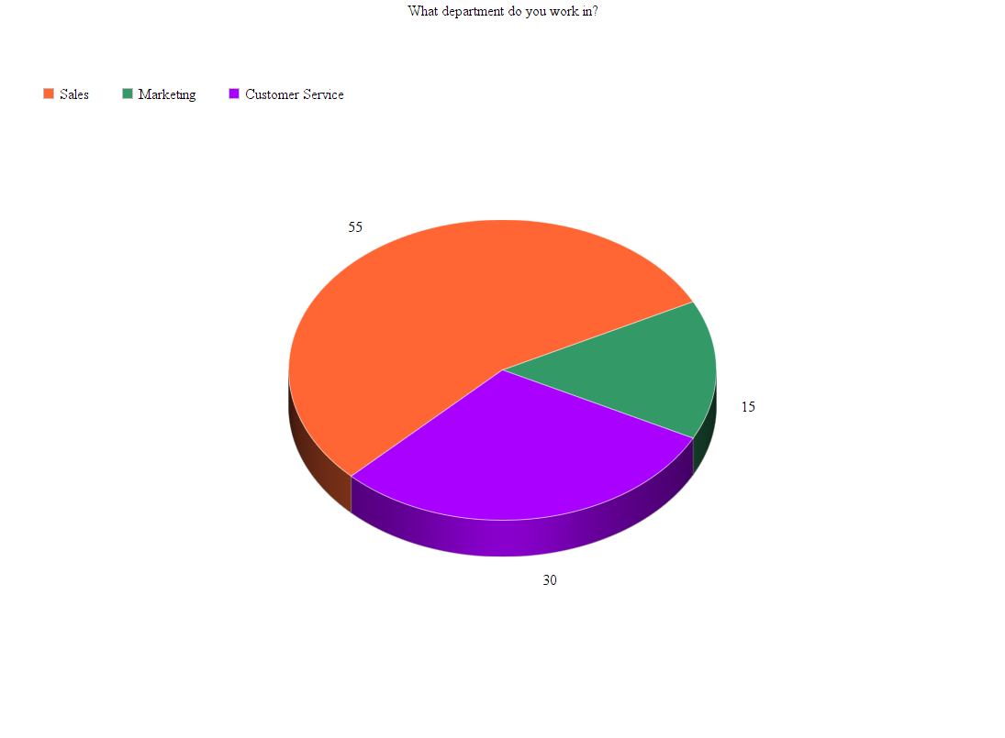

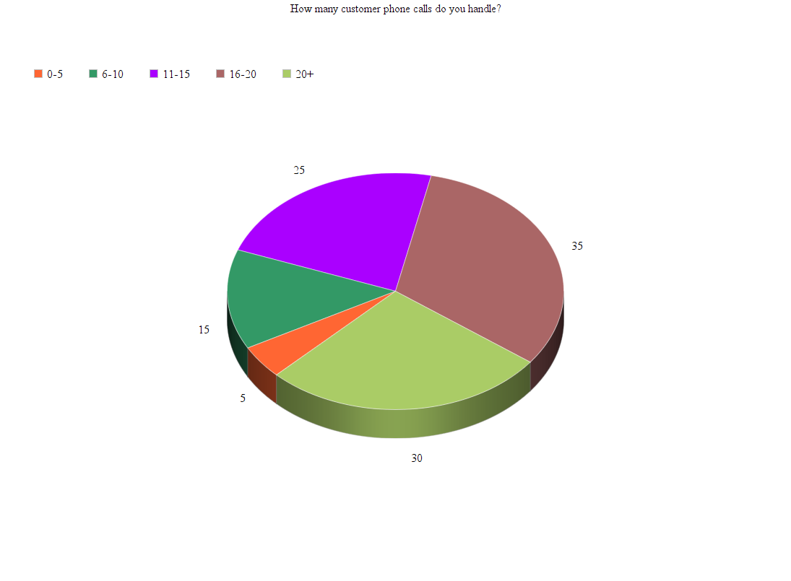

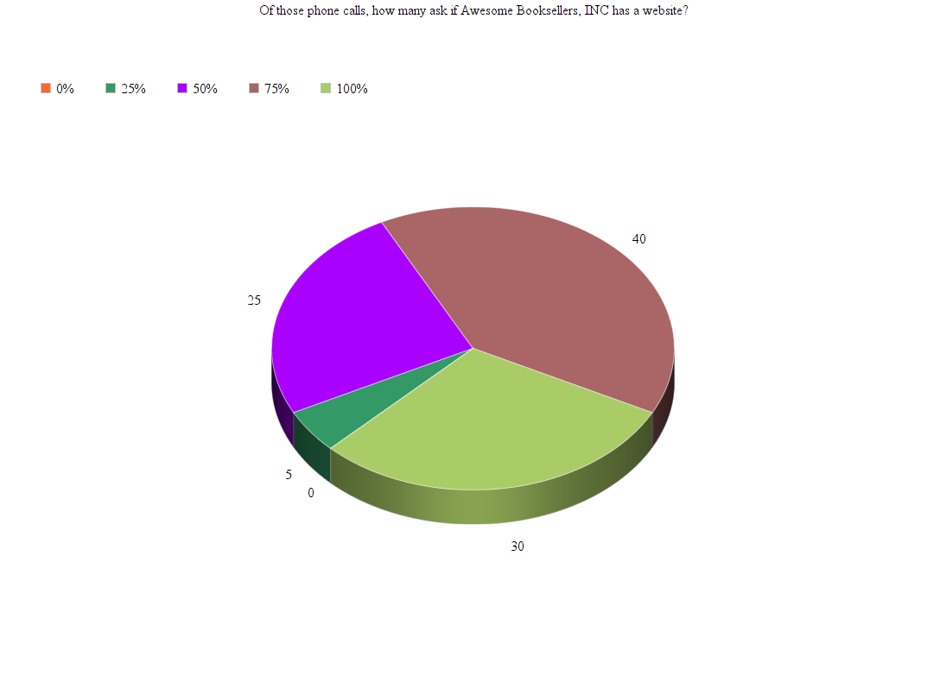

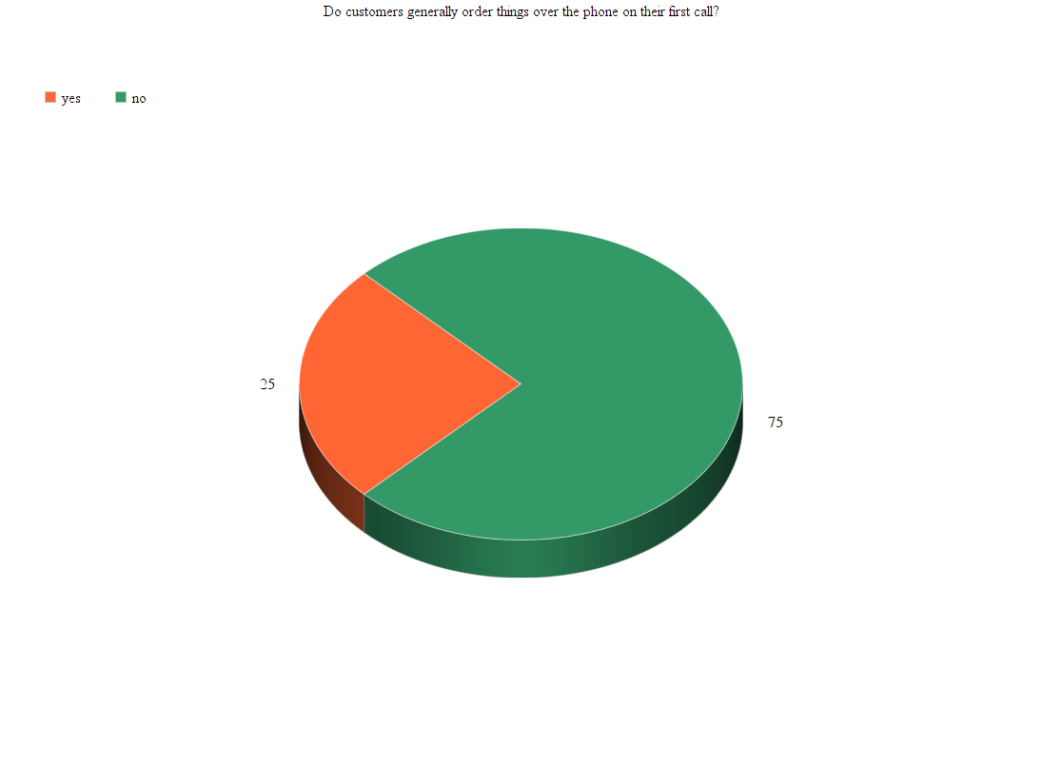

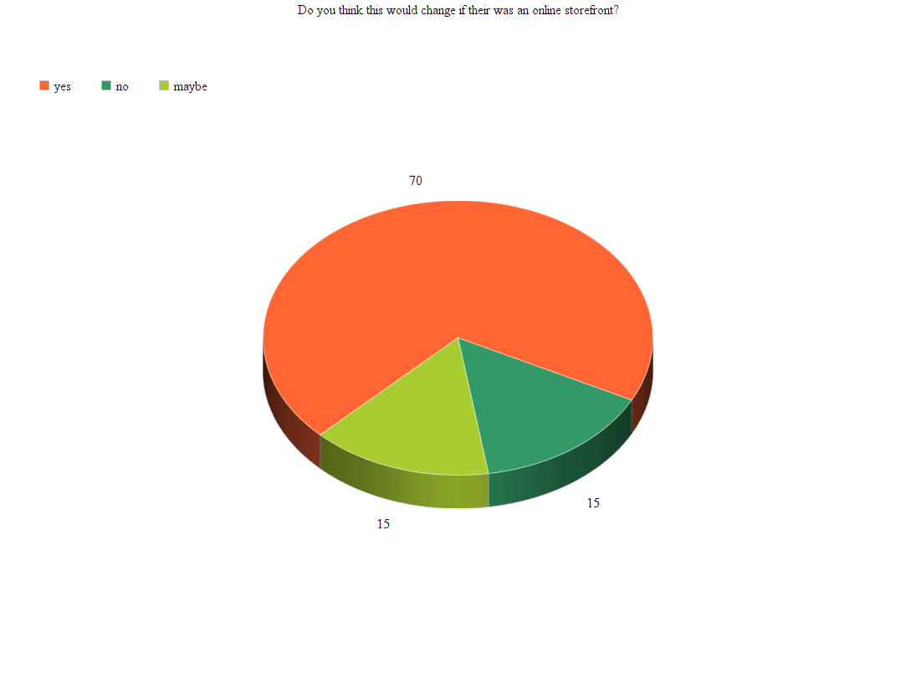

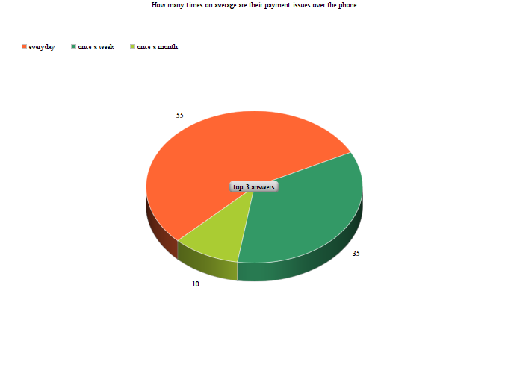

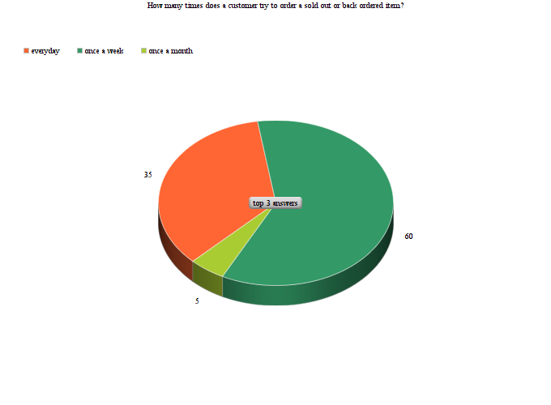

# Employee Survey Results

**Part 3**

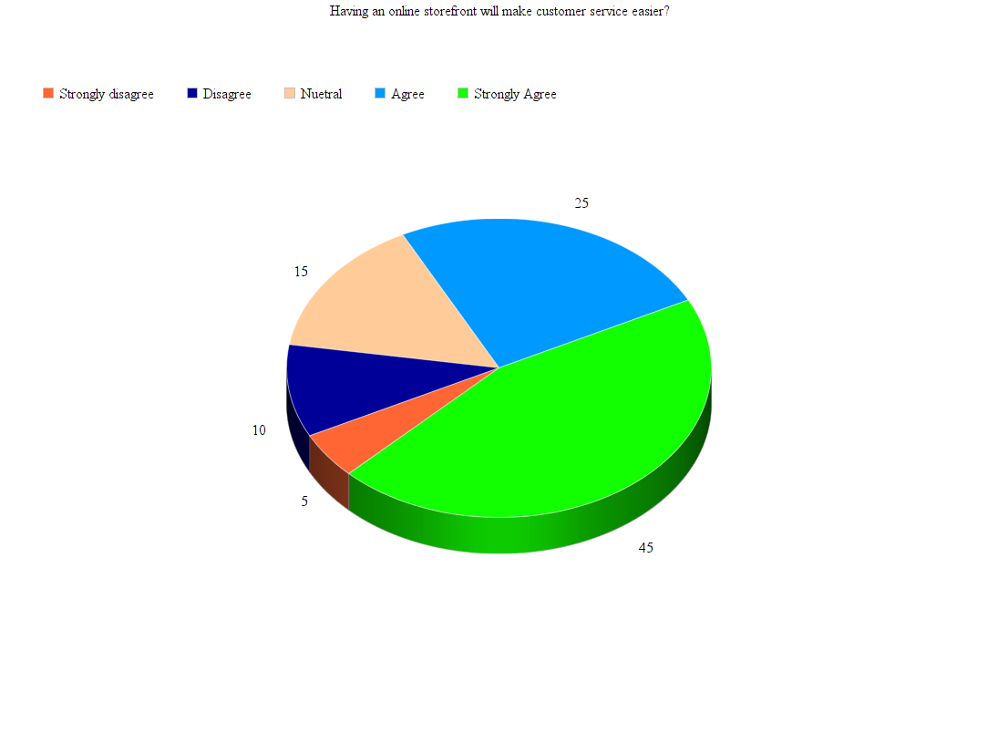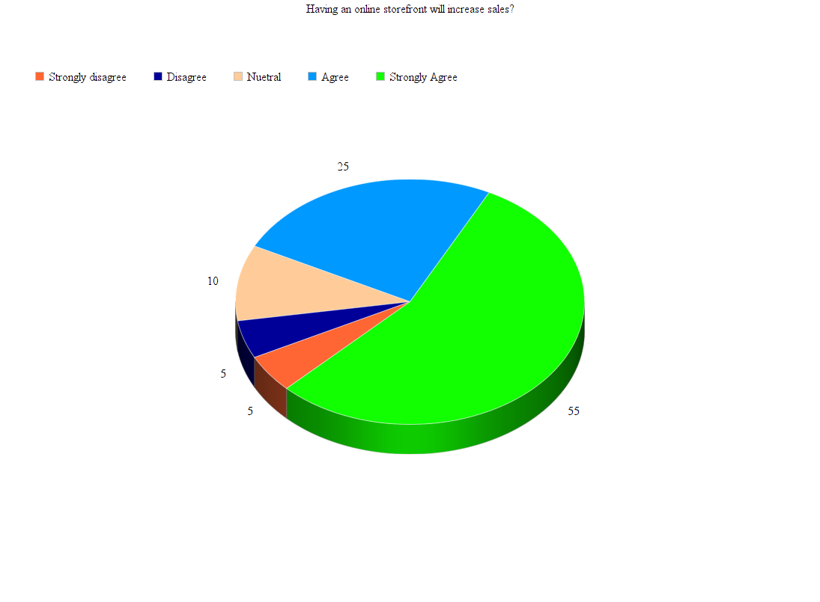

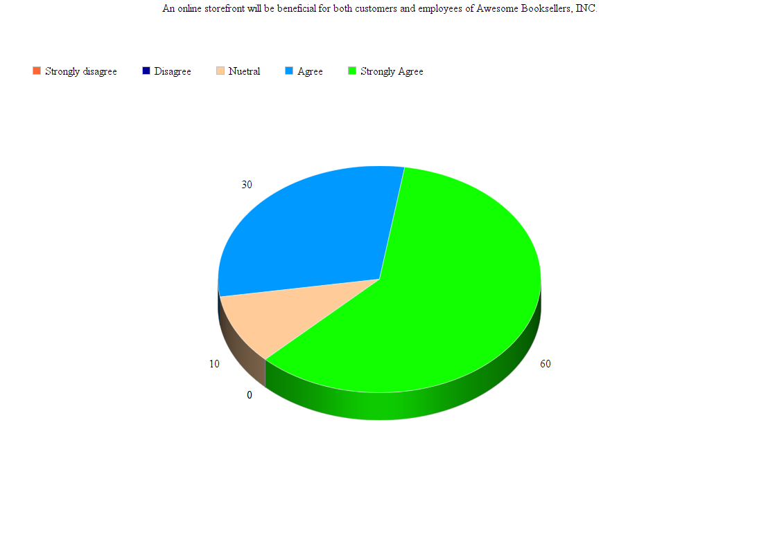

# Employee Survey Results

**Part 3**

What is the biggest obstacle to adding new customers? Top 3 answers:

1. Lack of a storefront to show them. 43%
2. Lack of proper products. 22%
3. Undesirable price. 10%

What isn’t working with the current system? Top 3 answers:

1. Extremely hard to keep customer information organized and accurate. 33%
2. Difficult to show customers different promotions. 24%
3. Tough to keep different promotions organized. 10%

What would you like to see added to the new online sales system? Top 3 answers:

1. Automatic checkout. 67%
2. Automated customer help for simple things. 20%
3. A way to easily upsell products. 5%

# Feasibility Issues

With adding the new website system to Awesome Booksellers, Inc. according to our understanding, the current system may have some issues with implementing every aspect of the company. Some potential things we are concerned about are:

* Computer Phobia.
* Fear of change of job responsibilities.
* Change of long-standing work procedures.
* Fear of loss of employment due to increased automation.

We plan to handle each of these fears differently for each department. With an organized plan, we should be able to solve most problems before they even arise within the team members.

1. **Computer Phobia**.
   1. We plan on holding a training class for Sales, Marketing, and Customer Service departments. During this training class, we will show them how they can use the new system effectively. After the training class we hold a Q and A session to help clear up any additional issues. There will also be occasional e-mails to be sent out that contain informational videos on how to do certain things within the system.
   2. We plan on showing all of the mail and dock workers how they can use the new system to help speed up their jobs. We will provide some hands on training as well as a training class.
2. **Fear of change of job responsibilities.**
   1. With the new system being implemented, team members are going to have some of their job roles changed. While most of their key tasks will remain the same, how they handle these jobs may change slightly. To prevent fear of the new things affecting work productivity, we are going to create an updated job description for every department. This will clearly lined out any new tasks that a team member may have to perform. If they have any questions about the new tasks they can talk to their immediate supervisor.
3. **Change of long-standing work procedures.**
   1. Many of the previous work procedures will have to be updated to accommodate the new online sales system. To prevent team members being upset about these changes we are going to develop a new list of procedures for each job. Immediate supervisors will develop these new lists and help their employees understand what must be done once the new system is in the place.
4. **Fear of loss of employment due to increased automation.**
   1. Although, the new system will automate many things that were previously done manually doesn't mean there is no need for employees. The employees whose jobs are becoming obsolete will be trained in the new procedures. For these specific employees, we will spend extra resources for their training to ensure that they understand all aspects of the new system.

# Project Estimates

|  |  |  |
| --- | --- | --- |
| **Iteration** | **Time Estimate** | **Use Cases Assigned to Iterations** |
| 1 | 6 Weeks | 1. Search for item. 2. View image. 3. Create customer account. |
| 2 | 5 Weeks | 1. View comments. 2. View promotions. 3. Add item to cart. |
| 3 | 4 Weeks | 1. Remove item from cart. 2. Save cart. 3. Check out. 4. Record a purchase. |
| 4 | 5 Weeks | 1. Create sales reports. 2. Track shipping. 3. Request a return. |
| 5 | 4 weeks | 1. Clean up. 2. Test website. 3. Tune database. |
| Total | 24 Weeks |  |

# 

# 

# 

# 

# 

# 

# 

# 

# 

# Risk Matrix

|  |  |  |  |
| --- | --- | --- | --- |
| **Likelihood** | **Consequences** | | |
|  | **Insignificant**  (Risk is easily mitigated by normal day to day process.) | **Moderate**  (Delays up to 30% of schedule and costs an extra 30% of budget.) | **Catastrophic**  (Project abandoned.) |
| **Certain**  >90% chance |  | Conflicts due to highly variable workloads and schedule changes. |  |
| **Moderate**  10-90% chance | Administrative problems. | Permanent loss of key personnel |  |
| **Unlikely**  3-10% chance | Policies and procedures not understood. | Insufficient spare parts inventory. | Test Equipment failure. |
| **Rare**  <3% chance | Unavailability of personnel due to accidents or injuries. | Computer system compromised. | Floods, Fire, Other natural disaster. |

# Domain Model Class Diagram

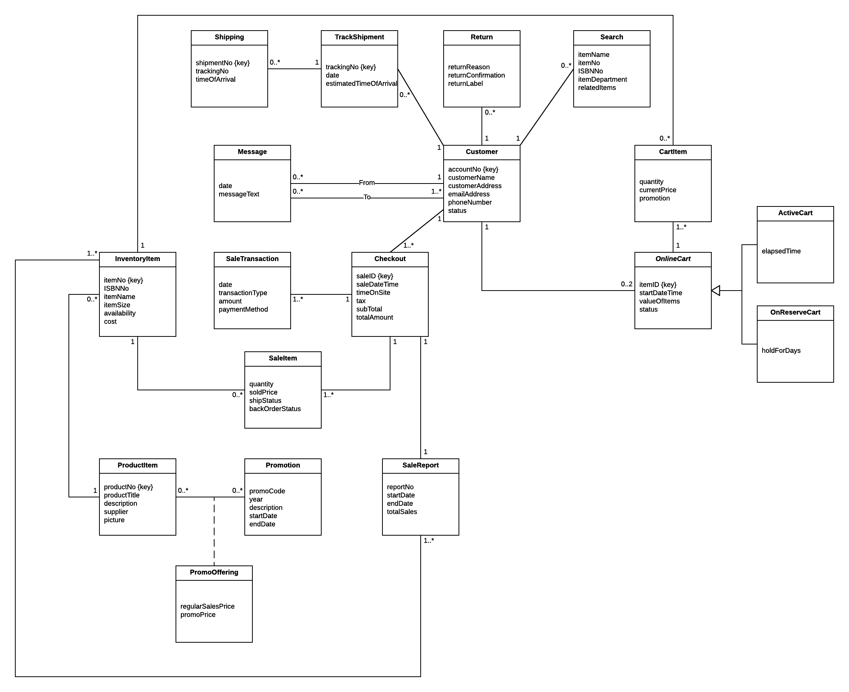

Network Diagram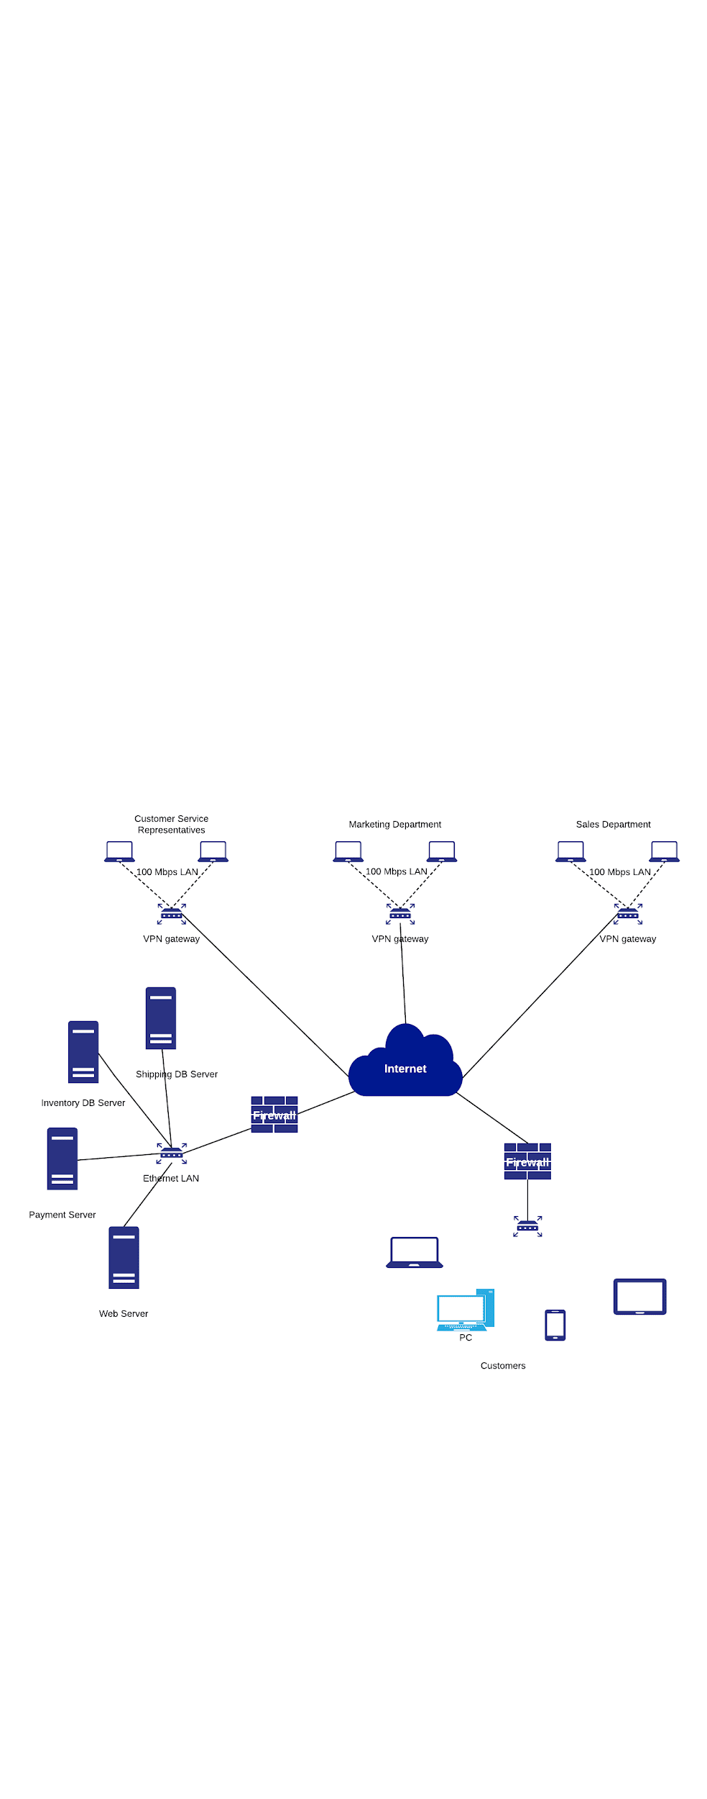

# 

**Final Cut Design Class Diagram**

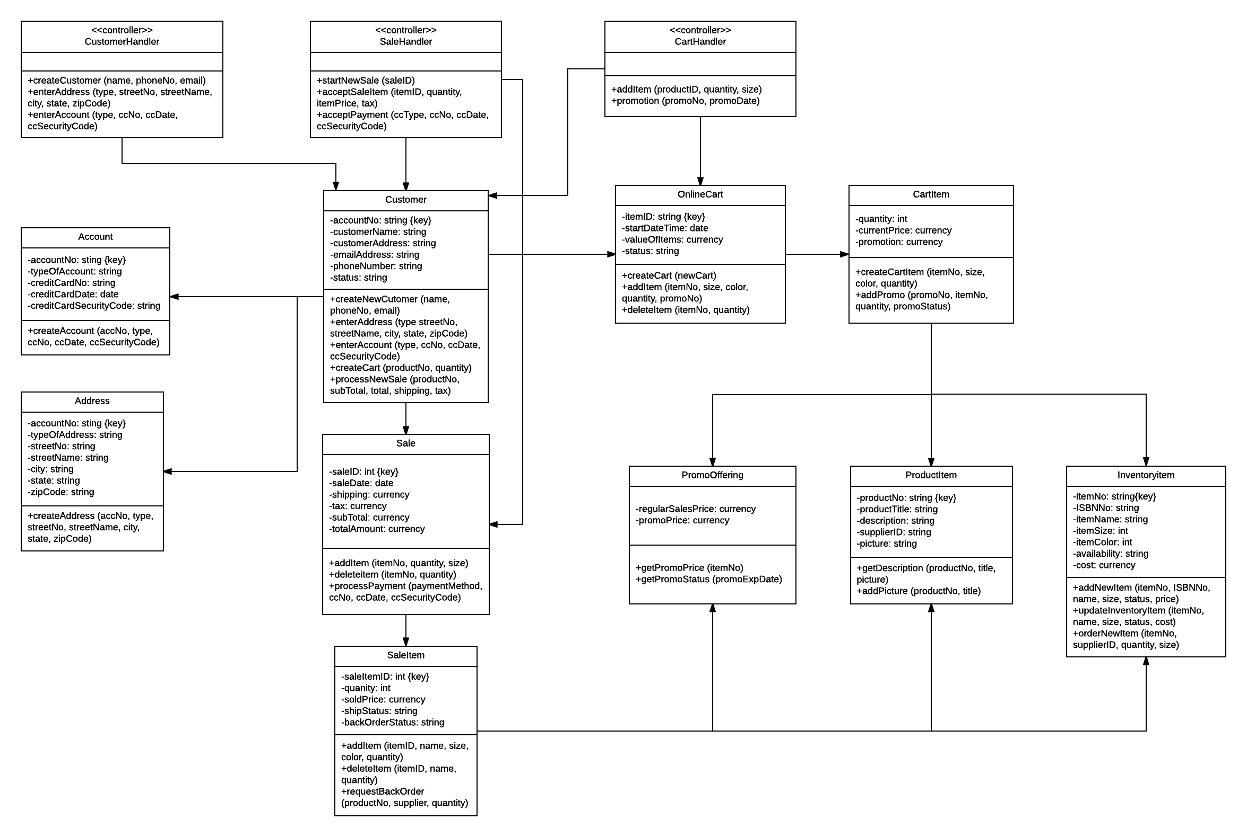

# Relational Database

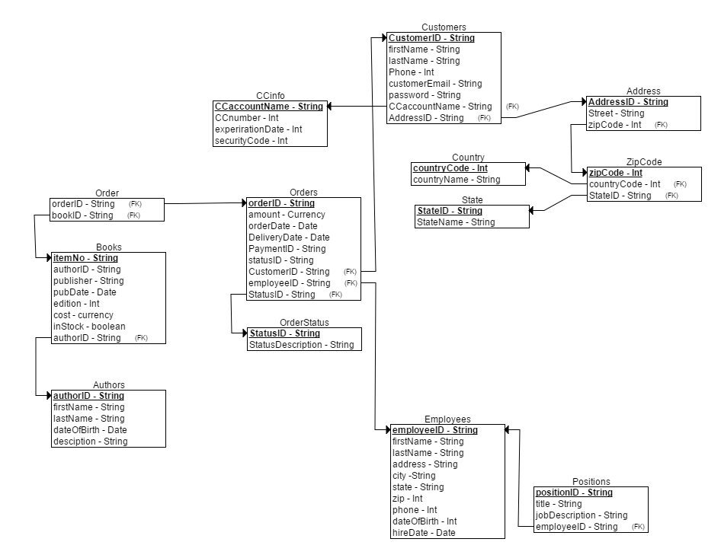

# List of Use Cases

|  |  |
| --- | --- |
| Use Cases | Users/actors |
| Search item(s) | Customer, Customer service representative, Marketing, Sales |
| Fill shopping cart | Customer |
| Checkout | Customer |
| Create new customer | Customer, Customer service representative |
| Ship Item(s) | Shipping |
| Send message | Customer, Customer service representative, Management, Shipping, Sales |
| Track shipment(s) | Customer, Shipping |
| Record a Purchase | Sales |
| Add/update product information | Customer service representative, Marketing |
| Add/update promotion | Customer service representative, Marketing |
| Request return | Customer |
| Produce daily transaction summary report | Management |

# Use Case Diagram

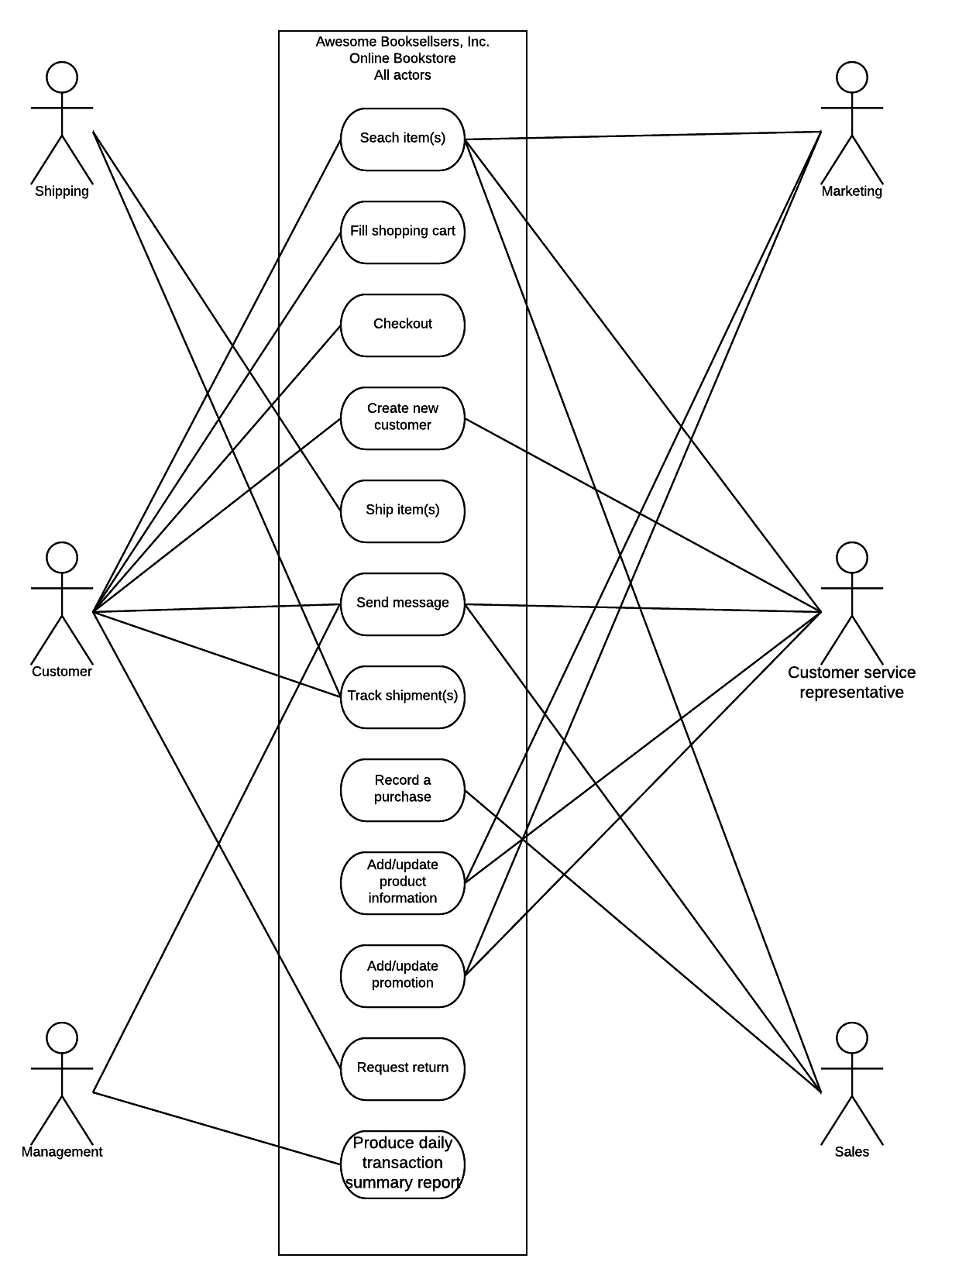

# Fully Developed use case #1

|  |  |  |
| --- | --- | --- |
| Use Case Name: | Search item. | |
| Scenario: | Search for an item on the website. | |
| Triggering event: | Customer wants to look up an item for purchase. | |
| Brief description: | Online customer wants to look for a specific item that they may want more information on and ideally follow the search up by adding the desired item to the shopping cart. | |
| Actors: | Customer | |
| Related use cases: | Might be invoked by the view product comments and ratings use case. | |
| Stakeholders: | Customer, Customer service representative, Marketing | |
| Preconditions: | Customer must be visiting the website.  One or more items must be entered into search box. | |
| Postconditions: | System searches database for customers search.  System displays search results. | |
| Flow of activities: | Actor | System |
| 1. Customer goes to website, and enters desired item into the search bar. 2. Once customer has entered desired search request, they submit the search. | 1.1 System accepts input into search bar.  2.1 System searches database for customers query.  2.2 System displays search results. |
| Exception conditions: | 1.1 Customer enters invalid characters or information.    2.1 System cannot connect to database to search for results.  2.2 System displays wrong search results. | |

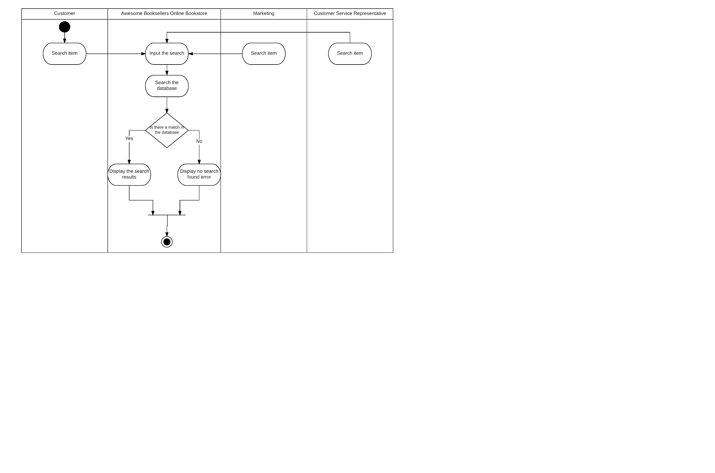

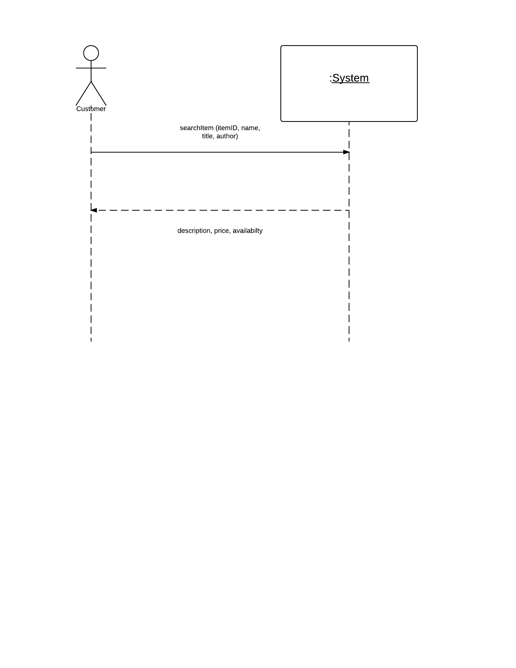

# Fully Developed use case #2

|  |  |  |
| --- | --- | --- |
| Use Case Name: | Fill shopping cart | |
| Scenario: | Item added to shopping cart | |
| Triggering event: | Customer desired adds item to shopping cart | |
| Brief description: | Online customer finds desired item they wish to purchase, they then add this item to the shopping cart so that they can proceed to checkout. | |
| Actors: | Customer. | |
| Related use cases: | Checkout, Empty Cart, Fill Reserve Cart, Empty Reserve Cart. | |
| Stakeholders: | Customer, Customer service representative, Marketing | |
| Preconditions: | Customer must have searched for an item. | |
| Postconditions: | Items added to shopping cart must be saved.  Shopping cart must be updated with current items.  System checks to make sure item is available to be added to cart. | |
| Flow of activities: | Actor | System |
| 1. Customer finds desired item and adds to shopping cart. | 1.1 System searches database to make sure item is available.  1.2 Systems stores the product in the shopping cart.  1.3 System prompts user a continue shopping or checkout message. |
| Exception conditions: | 1.1 System cannot find item that needs to be added to cart.  1.2 System fails to prompt customer.  1.3 Customer fails to answer prompt. | |

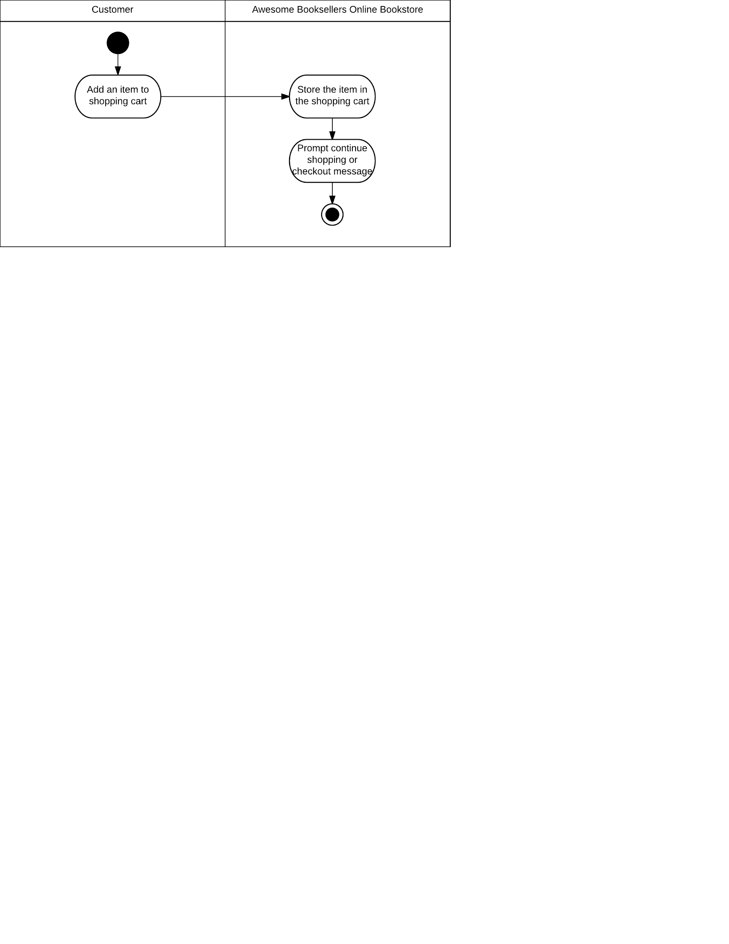

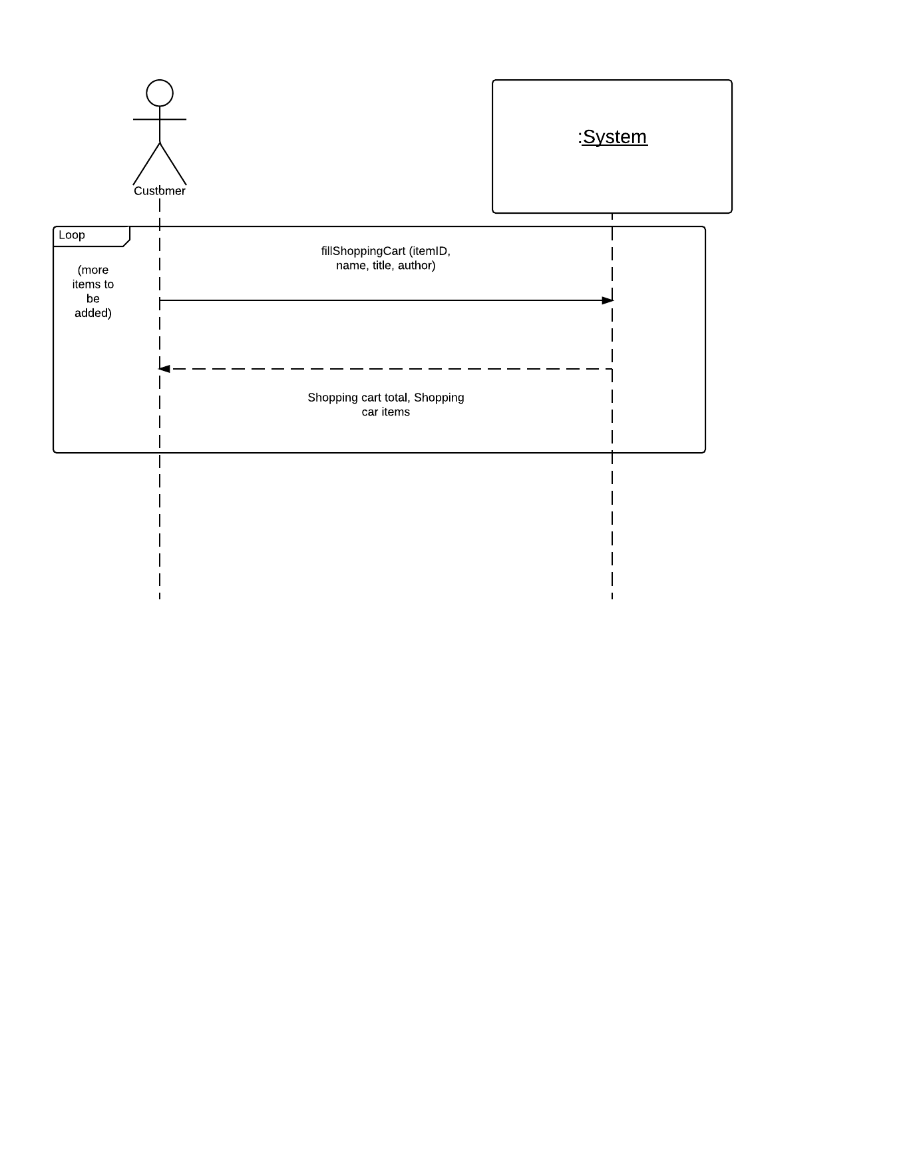

# Fully Developed use case #3

|  |  |  |
| --- | --- | --- |
| Use Case Name: | Create new customer. | |
| Scenario: | Create online customer account. | |
| Triggering event: | New customer would like to create an account for website. | |
| Brief description: | New customer creates an online account that will ask them for their basic information and follow up with extra shipping address and payment information. | |
| Actors: | Customer | |
| Related use cases: | Might be invoked by the Check out, and add item to shopping cart use cases. | |
| Stakeholders: | Customer, Customer service representative, Sales, Accounting. | |
| Preconditions: | Customer creation subsystem must be available.  System must be able to connect to payment information database. | |
| Postconditions: | Customer account must be saved.  Valid address and payment information must entered. | |
| Flow of activities: | Actor | System |
| 1. Customer visits website and wishes to create an account. 2. Customer enters a valid address and payment information. | 1.1 System creates a new customer account.  1.2 System asks for address and payment information.  2.1 System verifies address and payment information are valid.  2.2 System creates customer account and saves it to the database.  2.3 System emails customer validation link to activate account. |
| Exception conditions: | 1.1 Customer information is incomplete.  1.2 Invalid address or payment information  2.1 Address and/or payment information is invalid. | |

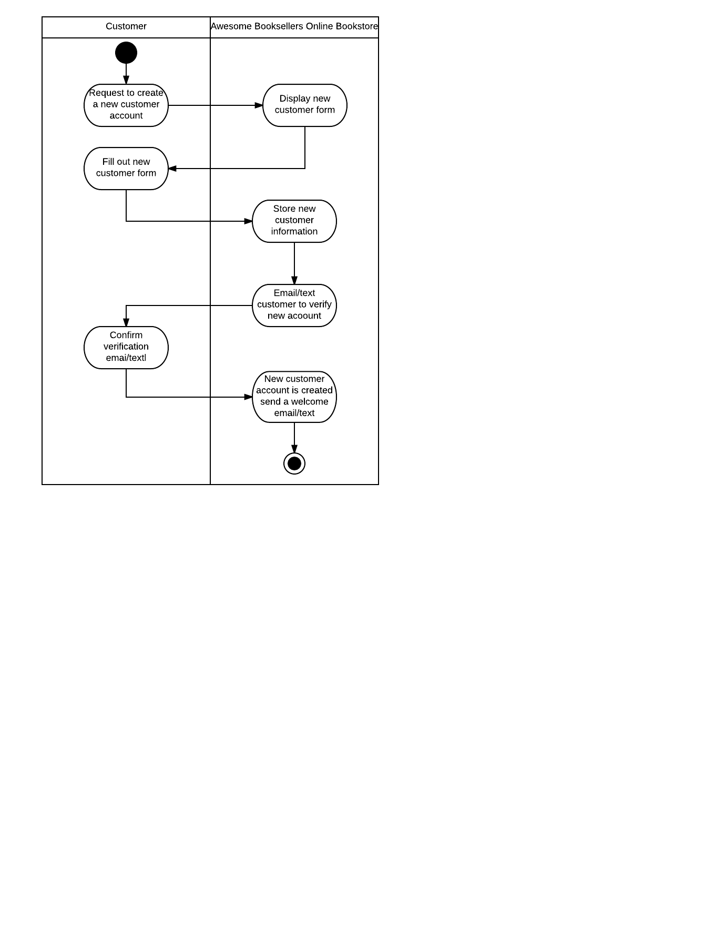

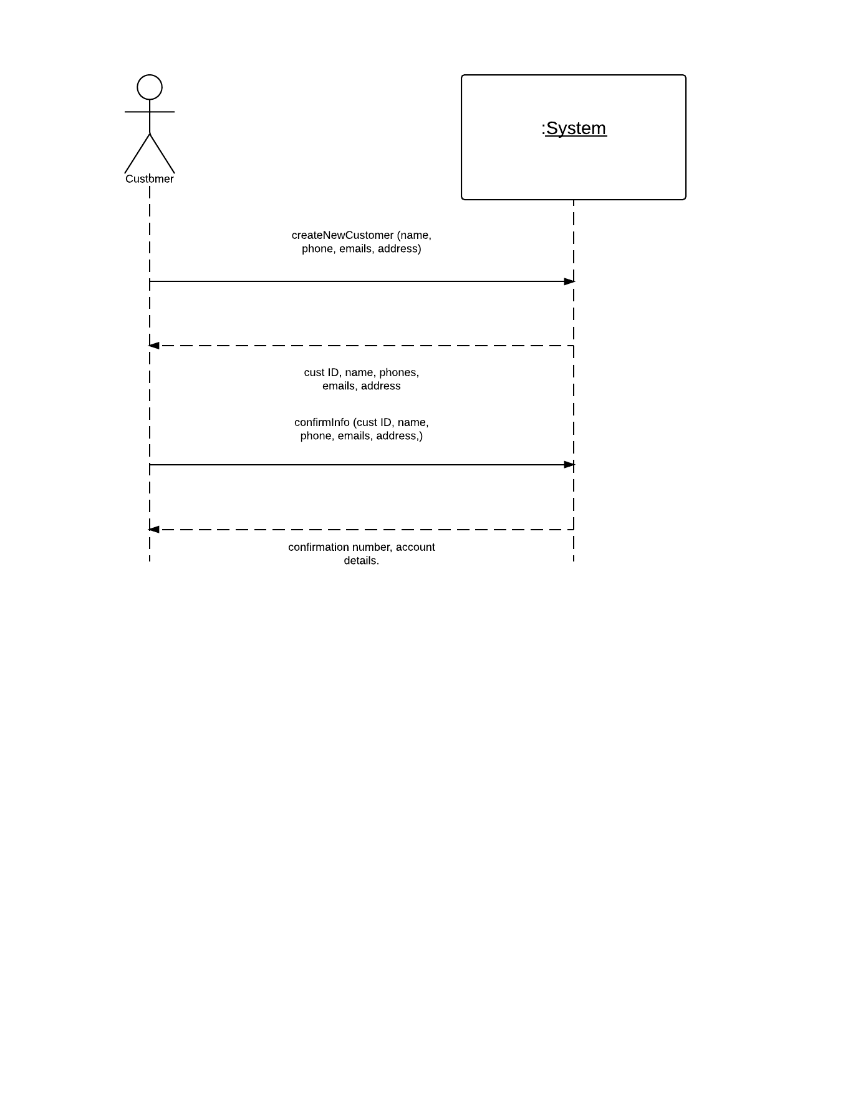

# Fully Developed use case #4

|  |  |  |
| --- | --- | --- |
| Use Case Name: | Checkout. | |
| Scenario: | Customer would like to checkout. | |
| Triggering event: | Customer wishes to buy the items that are in the shopping cart. | |
| Brief description: | A customer wishes to buy item from their shopping cart because they wish to finalize their purchase. | |
| Actors: | Customer | |
| Related use cases: | Might be invoked by the checkout use case. | |
| Stakeholders: | Customer, Sales, Customer service representative | |
| Preconditions: | Customer must have an item already inside their shopping cart. | |
| Postconditions: | Customer's shopping cart will have item(s) removed from it. | |
| Flow of activities: | Actor | System |
| 1. Customer wishes to buy items from their current shopping cart. 2. Customer selects a payment method and provides payment information. | 1.1 System prompts user to fill out the shipping information form.  1.2 System stores the shipping information.  2.1 System prompts customer to choose a payment method.  2.2 System prompts payment information form.  2.3 System stores the payment information.  2.4 System then prompts to checkout by displaying confirmation number and emails a copy to the customer. |
| Exception conditions: | 1.1 System cannot prompt the shipping information form.  1.2 System cannot communicate with the server to store the information.  2.1 System cannot communicate with secure payment server.  2.2 System cannot store the information.  2.3 Payment fails. | |

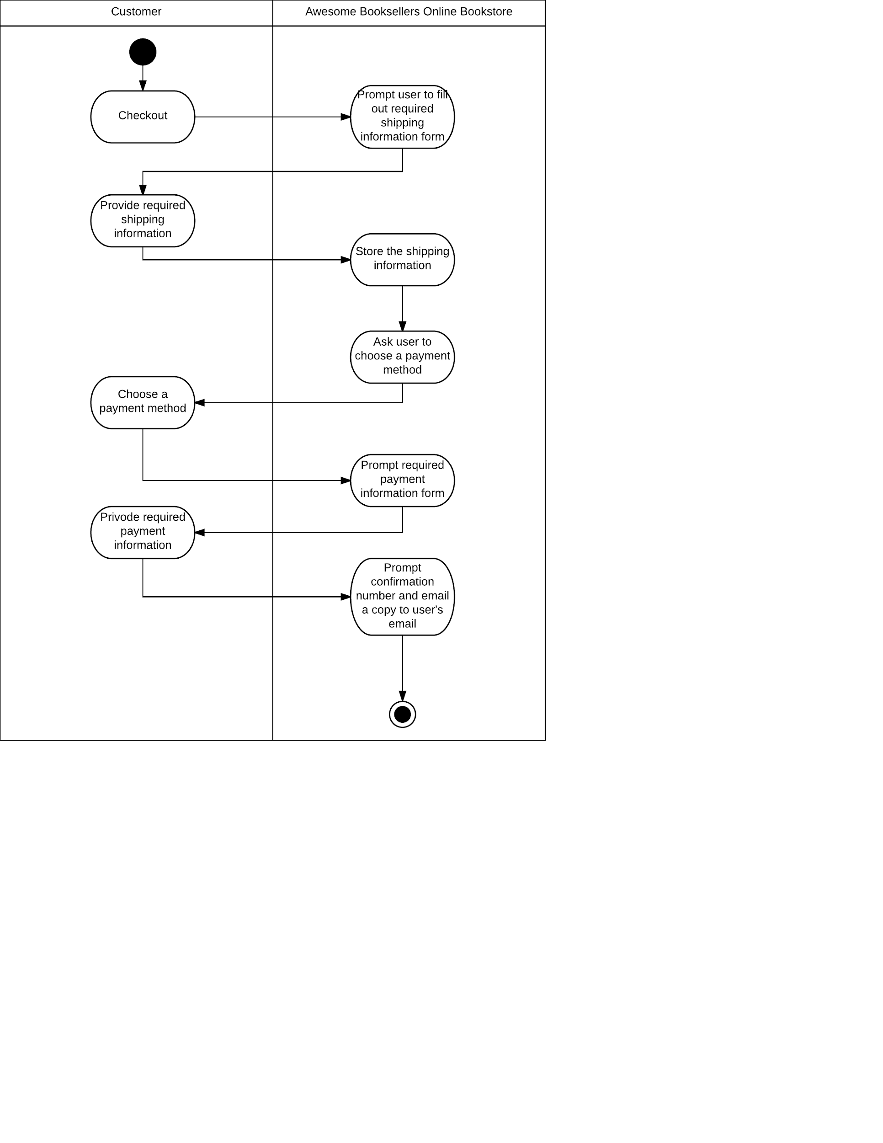

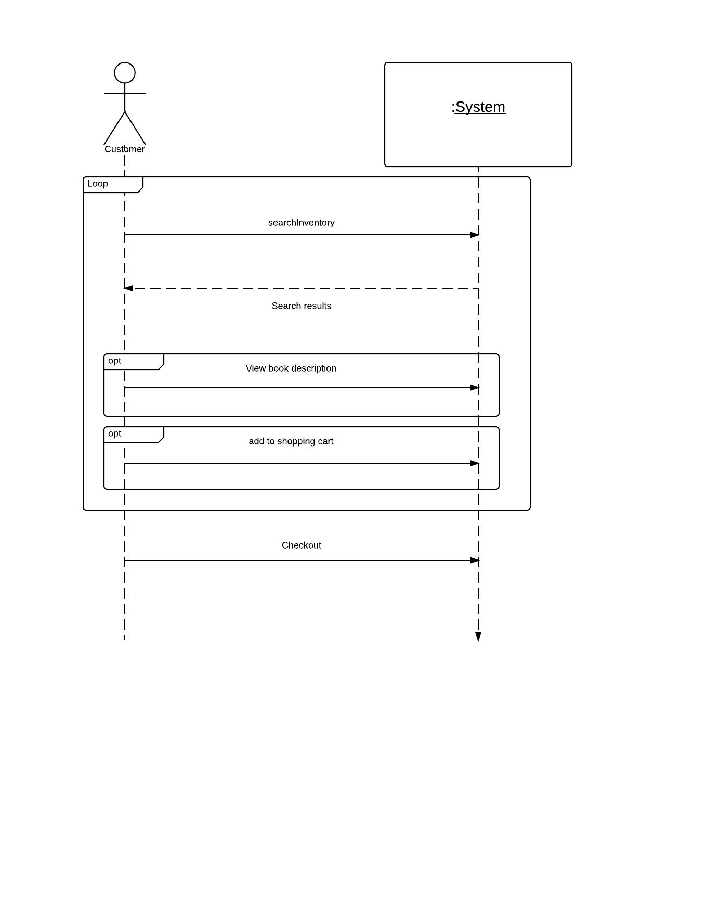,

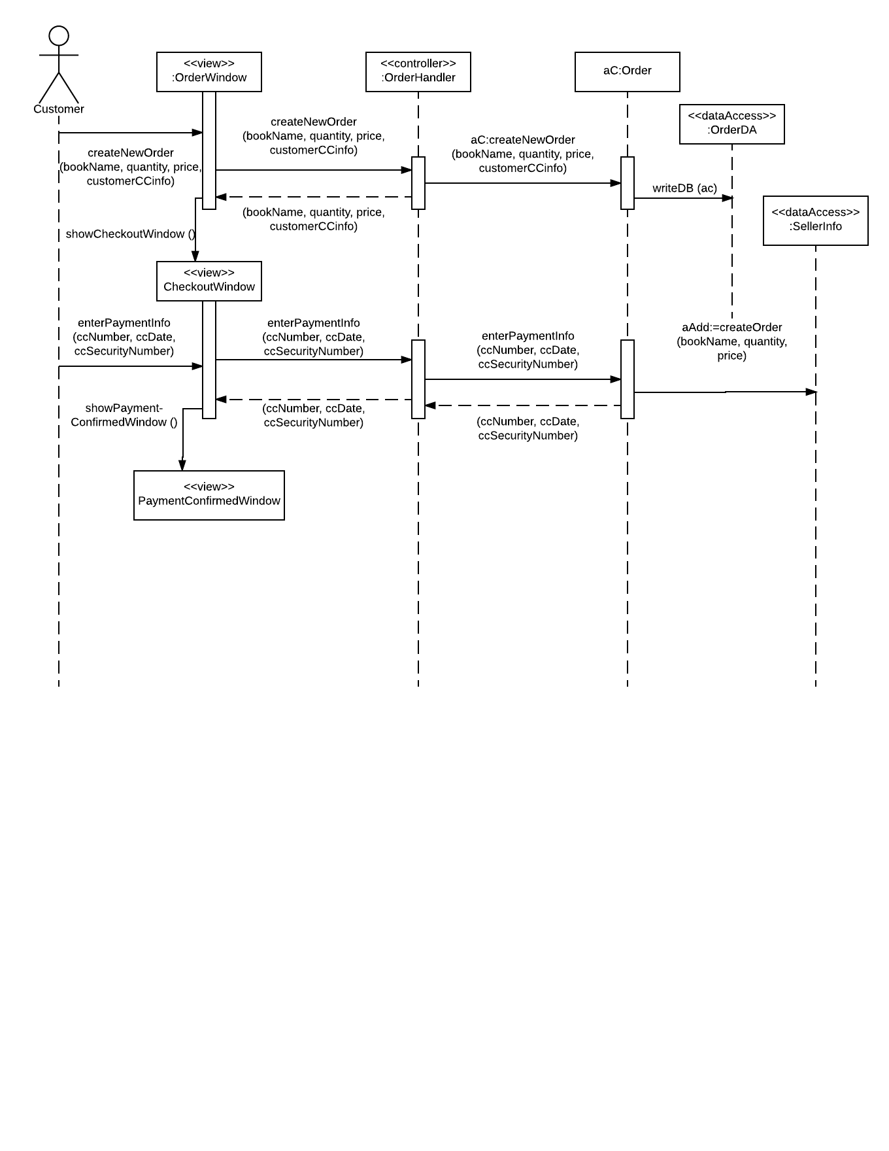

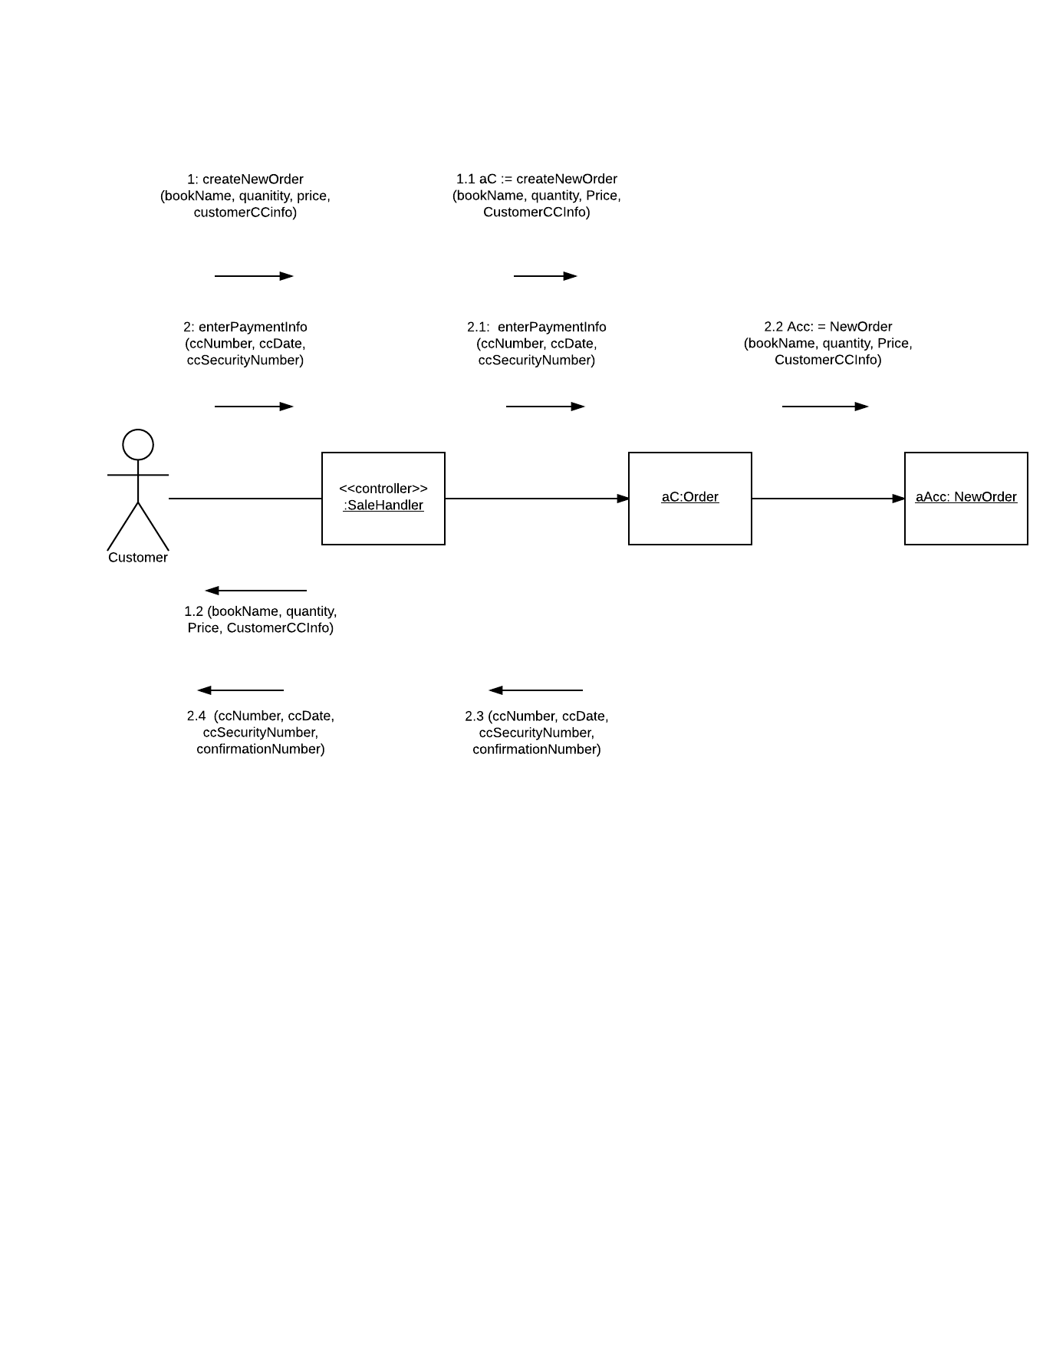

Addendum

During the design phase of this use case we ran into a few issues. The major thing that needed to be changed was that we needed to add data messages to the design diagrams. Our System Sequence diagrams did not contain of this information. If we were to redo the project then we would add these data messages at the start to make the later work easier. It would make creating the design diagrams a lot easier if we had consistent message names to reference. We added “enterPaymentInfo” and the “createNewOrder” message. We also added the all the data names that are seen in the above 2 diagrams. The design class diagrams follow the initial flow chart pretty well. We spent a lot of time making sure that these were correct, this helped us a lot in creating the later diagrams.

# Fully Developed use case #5

|  |  |  |
| --- | --- | --- |
| Use Case Name: | Ship item(s) | |
| Scenario: | Ship items that a customer ordered | |
| Triggering event: | Shipping is notified when a customer places an order. | |
| Brief description: | Shipping receives the sales details, find the items that need to be shipped, and sends out package to customer. | |
| Actors: | Shipping Clerk. | |
| Related use cases: | Might be invoked by the track shipment use case. | |
| Stakeholders: | Sales, Marketing, Shipping Clerk | |
| Preconditions: | Customer must have a verified address to ship items too.  A item checkout transaction has to exist.  The items that need to be shipped must be in stock. | |
| Postconditions: | Shipment items are gathered and attacked to shipper.  Shipped items are updated as they are gathered.  Unshipped items will be marked as unavailable or on backorder. | |
| Flow of activities: | Actor | System |
| 1. Shipping requests sales item information. 2. Shipping assigns Shipper. 3. Each item that is added to the order is recorded and updated. 4. If item is unavailable then the item is marked as unavailable or on backorder. 5. Items are Shipped. 6. Customer receives items. | 1.1 System looks for checkout information.  2.1 System creates shipment and assigns it to a shipper.  3.1 System updates sales order as it is checked in.  4.1 System marks items on backorder.  5.1 System notifies customer that their items have been shipped. |
| Exception conditions: | 2.1 Specific shipper is unavailable.  3.1 Item is damaged when shipper goes to add it to the order.  3.1 if item bar code wont scan, shipper must enter it manually.  5.1 System cannot connect to database to automatically send customer a notification. | |

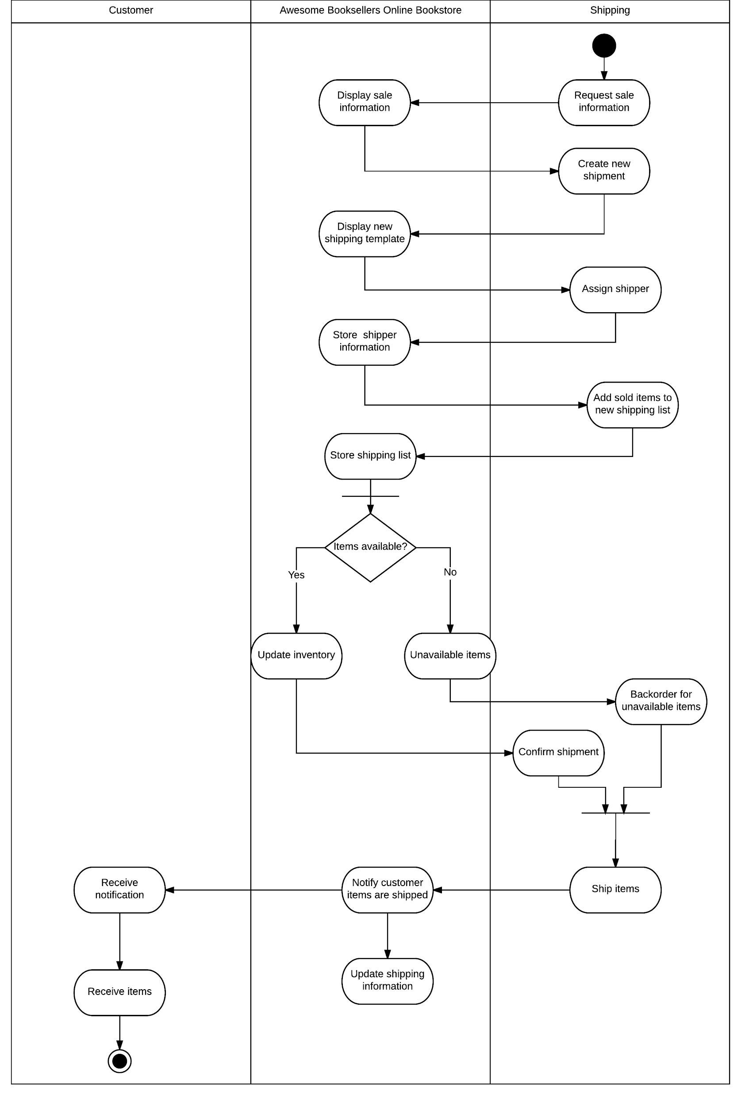

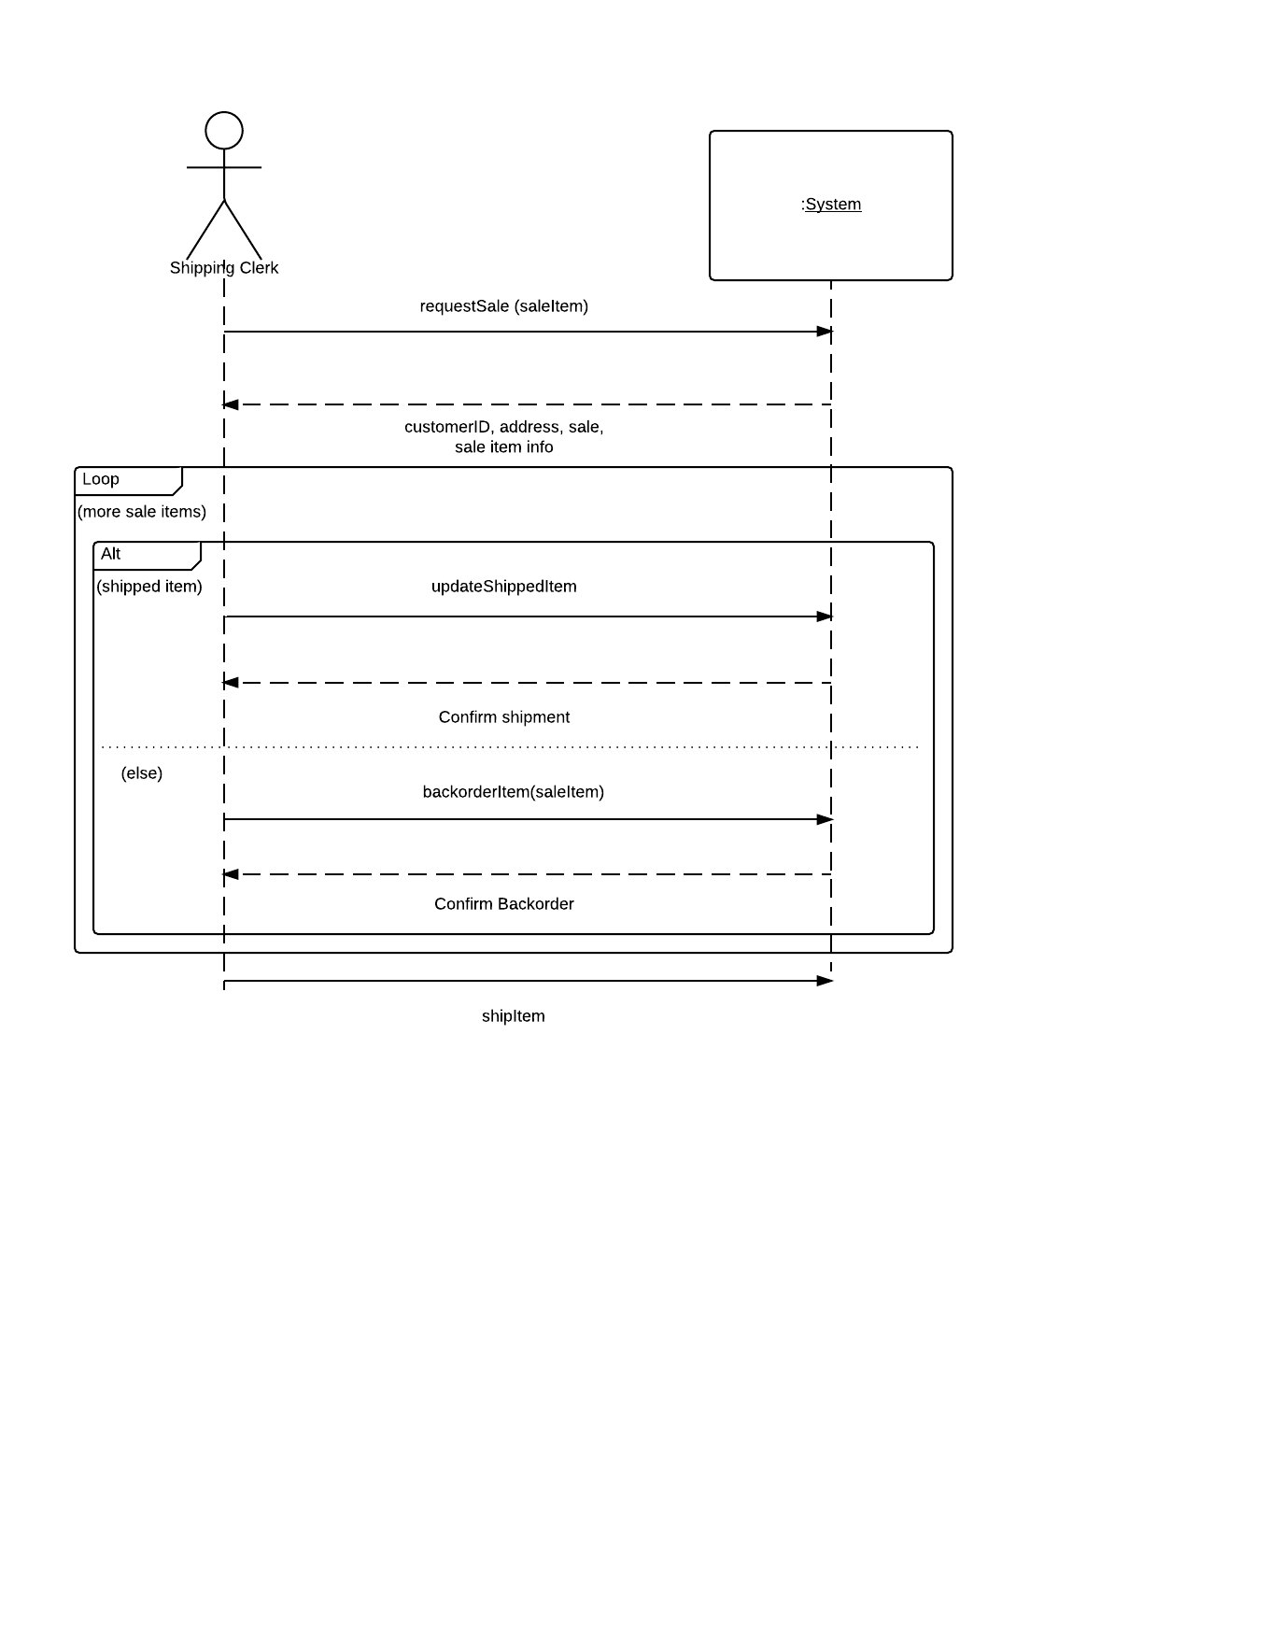

# 

# 

# 

# 

# sequence ship item - Page 1.png

# 

# 

# 

# 

# 

# Blank Diagram - Page 1 (4).png

# 

Addendum

Use case 5 “ship item” was a very complex use case that gave us a lot of trouble. Our system sequence diagram was lacking a lot of the necessary information that would have been extremely helpful later on in the design phase. We had very simple messages and data transfers. We had to create a lot of new names or changed a lot of the old ones so they made sense in the new diagrams. The overall flow of the design diagrams mirrored the activity chart greatly. If we had a chance to do another iteration of analysis we probably would have greatly expanded on our preliminary diagrams in order to ensure a smoother development process.

# Fully Developed use case #6

|  |  |  |
| --- | --- | --- |
| Use Case Name: | Send message. | |
| Scenario: | Customer wishes to send a message. | |
| Triggering event: | Customer wants to send a message to a customer service representative. | |
| Brief description: | Customer is have an issue with some part of the website and needs to contact a customer service representative for help. | |
| Actors: | Customer, Customer Service Representative | |
| Related use cases: | Could potentially lead to almost any other use case that would affect the customer, depending on the issue. | |
| Stakeholders: | Customer, Customer Service Representative | |
| Preconditions: | Customer must have account created.  Customer must have the message system interface opened.  Customer must have a message for the representative to answer. | |
| Postconditions: | Message is sent to customer service representative.  Representative can return a message or direct the customer into the right place. | |
| Flow of activities: | Actor | System |
| 1. Customer has some issues with website and would like to contact a Customer Service Representative. 2. Customer enters message they would like the customer service representative to help with.   3. Customer Service  Representative sends a response to customer. | 1.1 System opens messaging interface.  1.2 System prompts customer to enter a message that will be sent.  2.1 System connects to the customer service representatives computer  2.2 System sends message to representative.  2.3 System prompts representative to enter a response.  3.1 System sends message back to customer.  3.2 System repeats transmission back and forth until Customer Service Representative ends the transmission. |
| Exception conditions: | 1.1 System can’t connect to System Messaging interface.  1.2 Customer enters invalid information into message box.  2.1 System cannot connect to Customer Service Representative.  2.2 Message doesn't get delivered.  2.3 Representative enters invalid information into message box.  3.1 Customer doesn't receive message back.  3.2 System drops message transmissions.  3.2 Customer Service Representative does not end transmission. | |

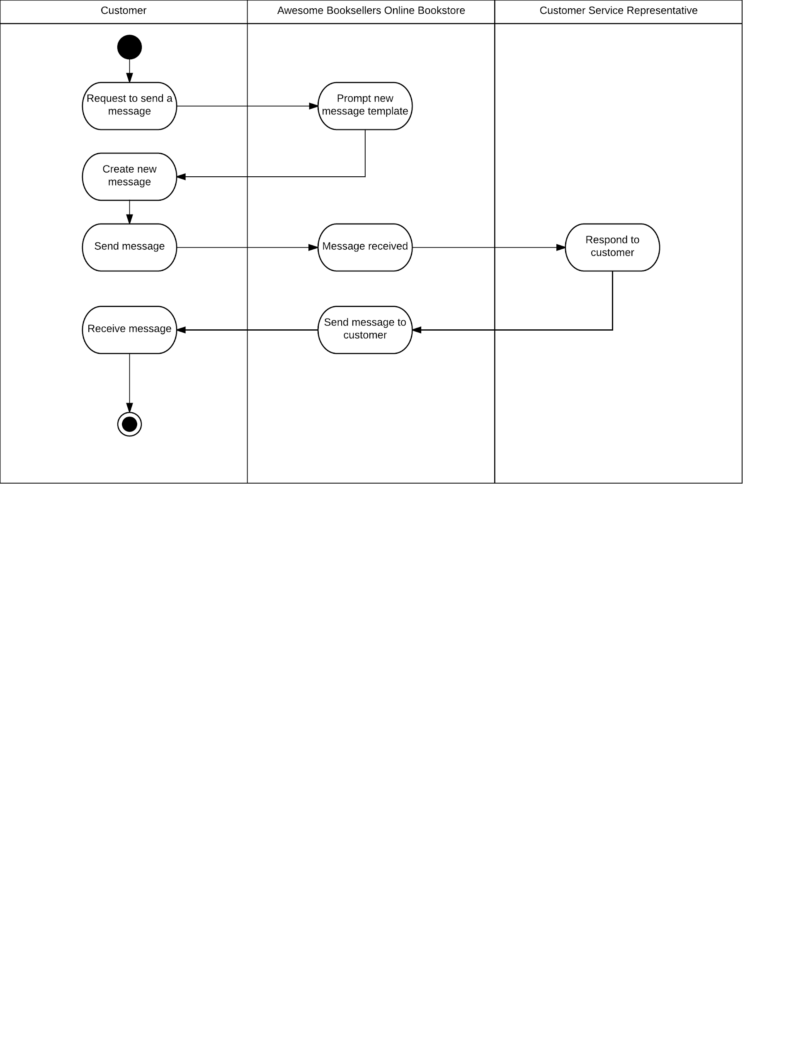

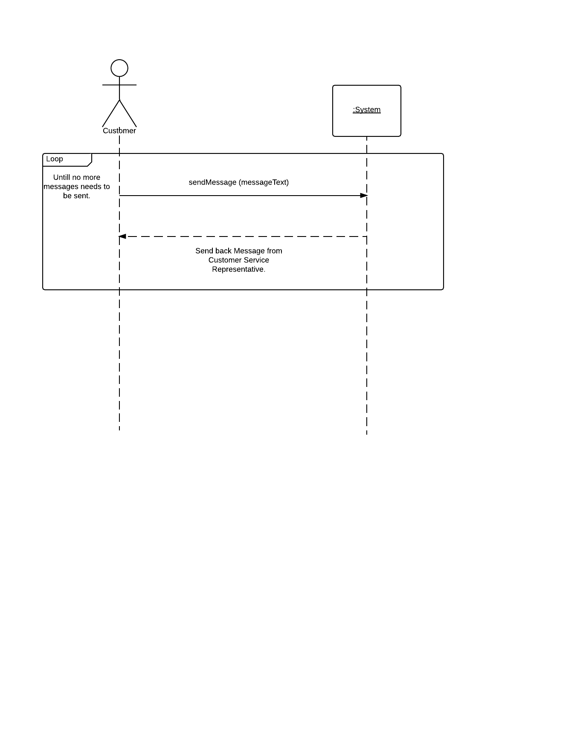

# Fully Developed use case #7

|  |  |  |
| --- | --- | --- |
| Use Case Name: | Track shipment(s). | |
| Scenario: | Customer tracks shipment | |
| Triggering event: | Customer wishes to see where their shipment is. | |
| Brief description: | Customer who has already purchased an item wishes to find out where their item is, and how long it will take to be delivered to them. | |
| Actors: | Customer, Shipping Clerk | |
| Related use cases: | Might invoke the Checkout and ship item use cases. | |
| Stakeholders: | Customer, Customer service representative, Shipping, Shipping Clerk | |
| Preconditions: | Customer must have already purchased an item from the online store.  Shipping clerk has to have already shipped the item. | |
| Postconditions: | Customer will receive an email showing where their item is and approximately how long it will take to reach the desired address. | |
| Flow of activities: | Actor | System |
| 1. Customer wants to look up where their purchased items currently are. | 1.1 System connects with shipper database.  1.2 System searches database for customer’s order.  1.3 System displays current location of the shipment.  1.4 System displays estimated time of arrival. |
| Exception conditions: | 1.1 System cannot connect to item database.  2.1 Customer enters invalid confirmation number. | |

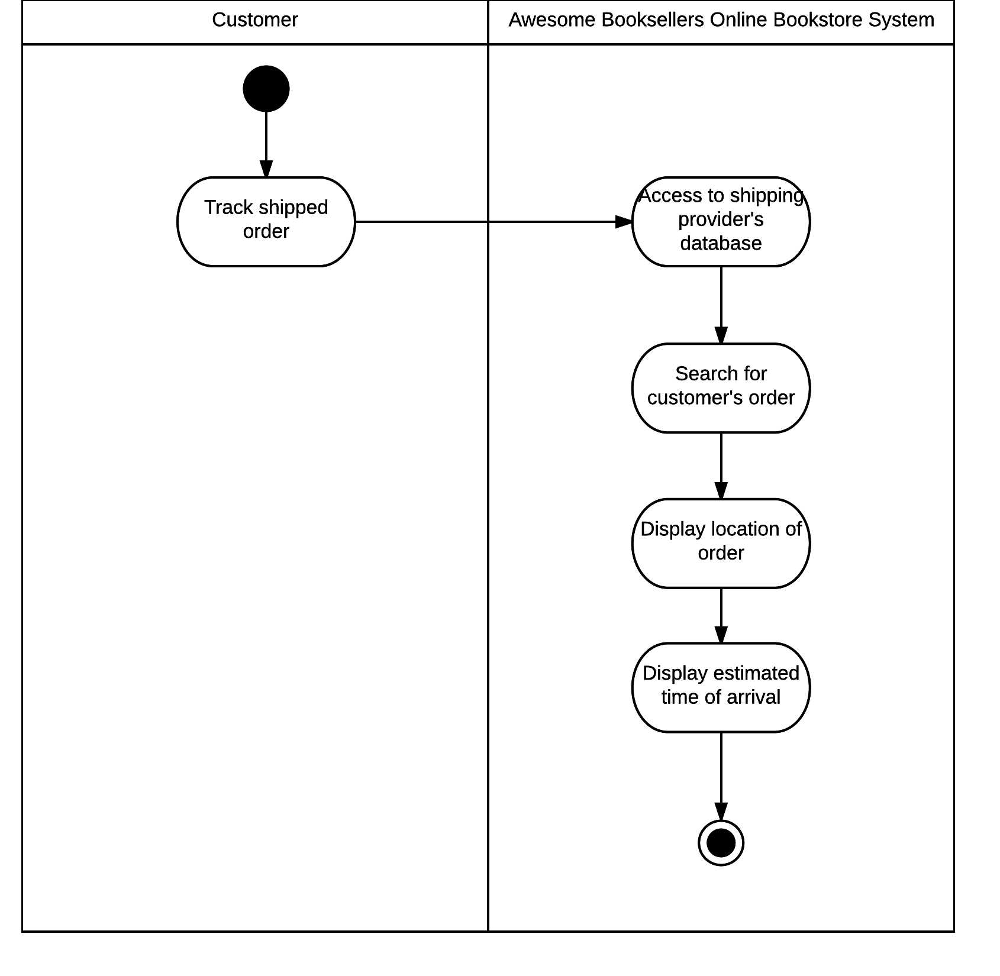

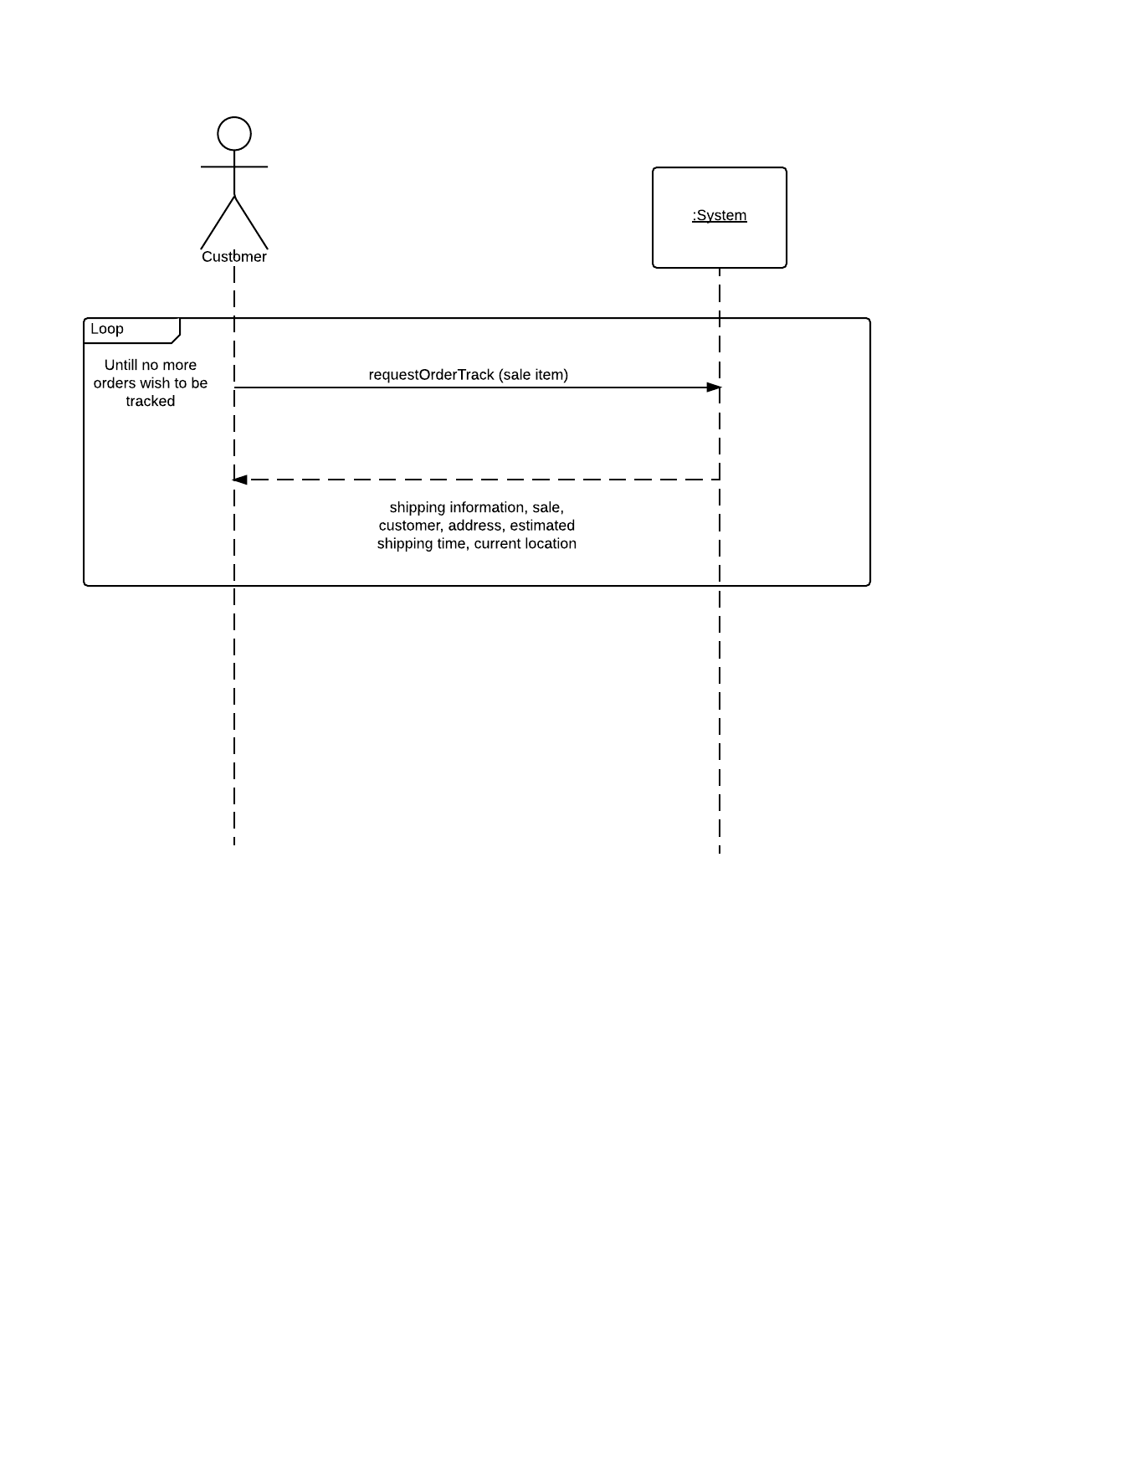

# Fully Developed use case #8

|  |  |  |
| --- | --- | --- |
| Use Case Name: | Record a purchase. | |
| Scenario: | Customer purchases books | |
| Triggering event: | Customer completes a purchase from the online store. | |
| Brief description: | Records and updates the book order information that was purchased by the customer. | |
| Actors: | Customer, Sales. | |
| Related use cases: | Might be invoked by Add or update product information, Search Book Index, and Email Seller. | |
| Stakeholders: | Customer, Sales. | |
| Preconditions: | Purchase must be made by customer.  Sales must have book available. | |
| Postconditions: | Seller is informed of purchase.  Book Index is updated.  Sales must notify customer of book status. | |
| Flow of activities: | Actor | System |
| 1. Customer purchases a book through the website. 2. Sales notifies system of book status. | 1.1 System maintains an open order.  1.2 System notifies sales.  2.1 System updates book status.  2.2 System updates book index information. |
| Exception conditions: | 1.2 Invalid Sales information.  2.1 Invalid book information. | |

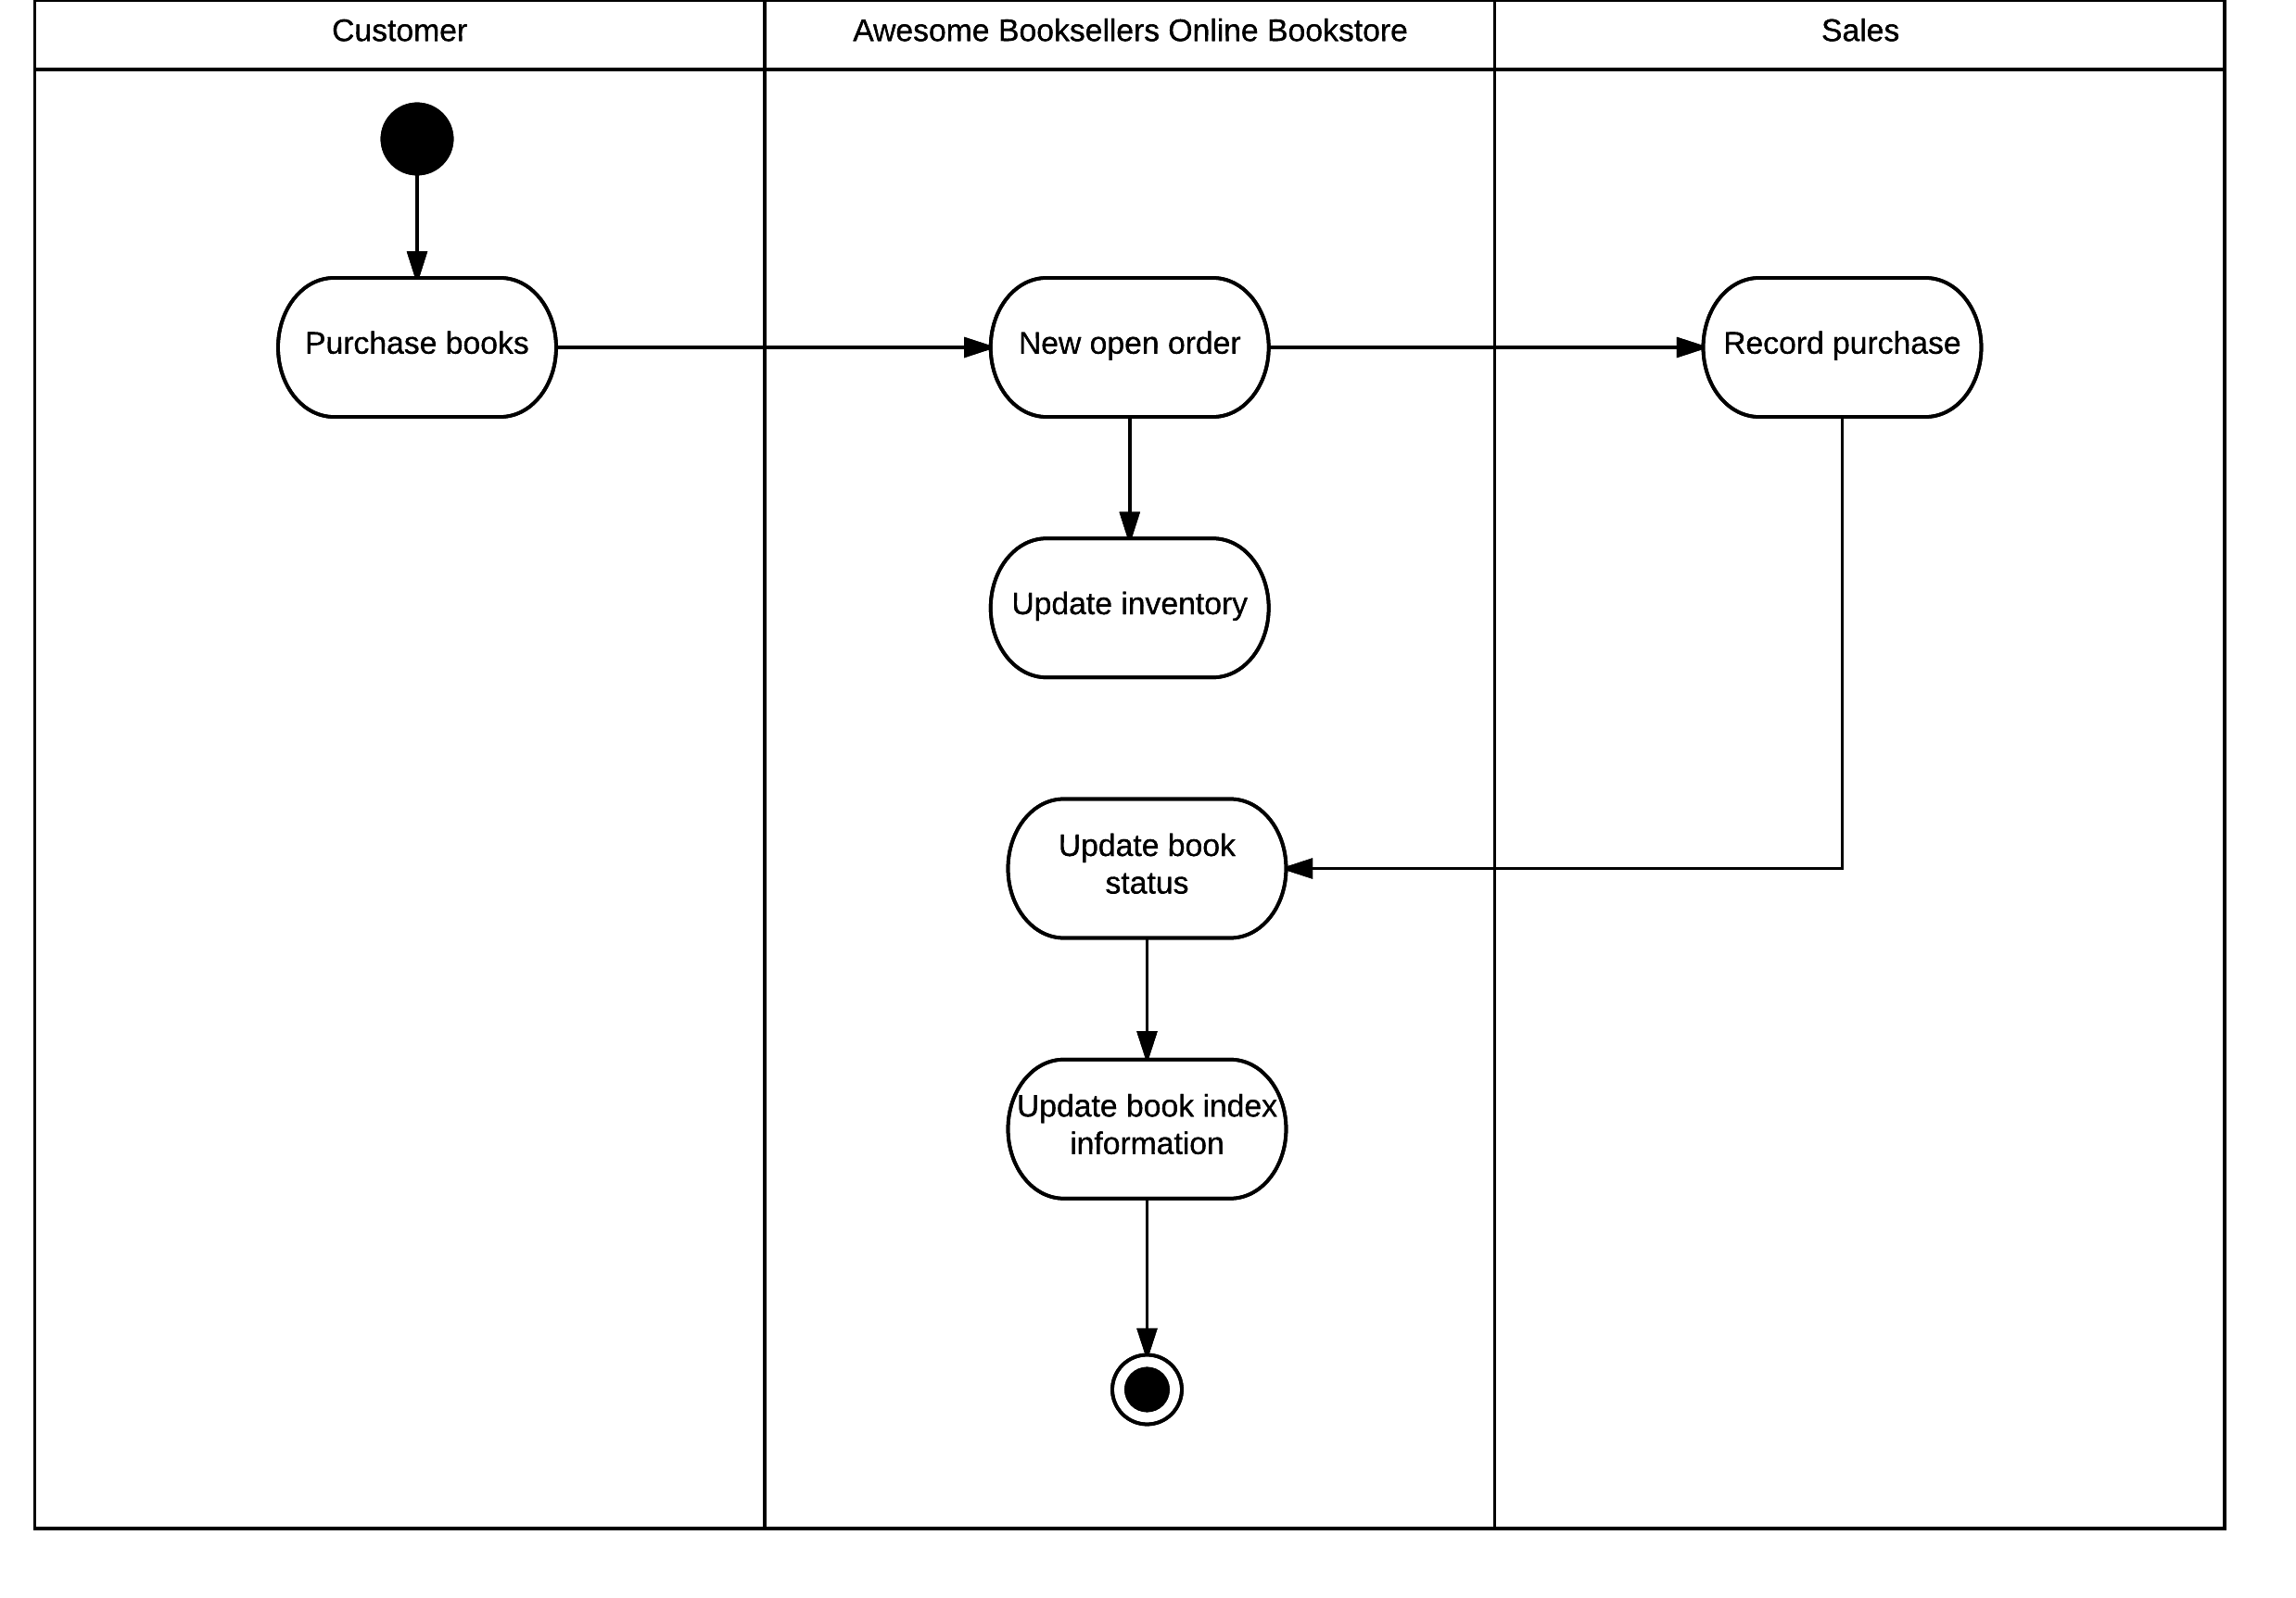

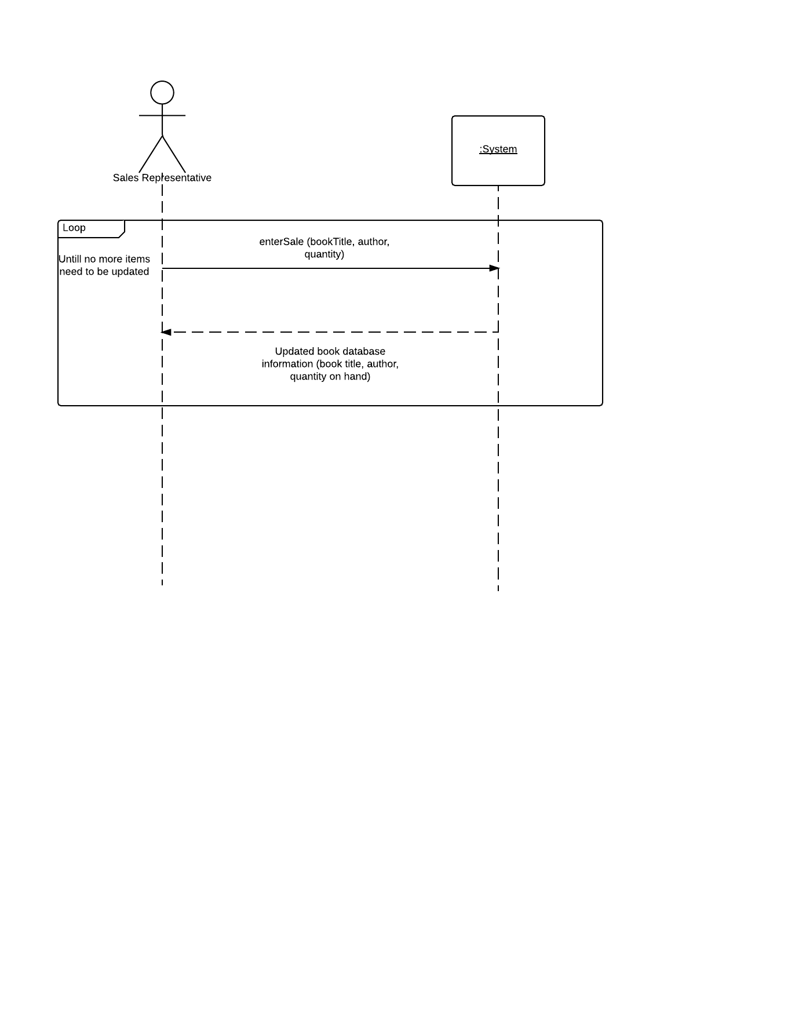

# Fully Developed use case #9

|  |  |  |
| --- | --- | --- |
| Use Case Name: | Add/update product information. | |
| Scenario: | New item is added to book database. | |
| Triggering event: | Item information needs to be added about a new product. | |
| Brief description: | The website wishes to add a new product to sell on their online store. The item information must be added to the database. | |
| Actors: | Sales | |
| Related use cases: | Might be invoked the the search item use case. | |
| Stakeholders: | Sales, Customer. | |
| Preconditions: | Book Database must be accessible.  Item information must be known. | |
| Postconditions: | Product information will be added to the database about a Cart Specific item. | |
| Flow of activities: | Actor | System |
| 1. Sales person wishes to add a new item to the online store. 2. Sales person enters desired product information. | 1.1 System will open up the item database.  1.2 System will prompt Sales person to add new product information.  2.1 System prompts sales person if more information needs to be input.  2.2 System adds item to database. |
| Exception conditions: | 1.1 System cannot connect to the store database.  1.2 System prompt fails,  2.1 Item information is wrong or invalid.  2.2 System cannot connect to item database. | |

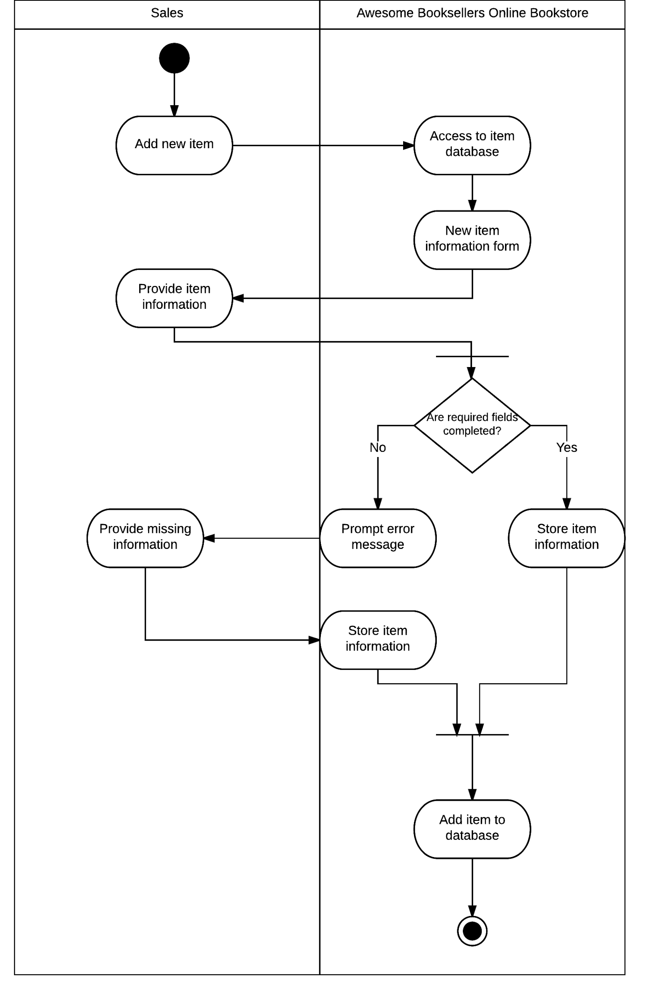

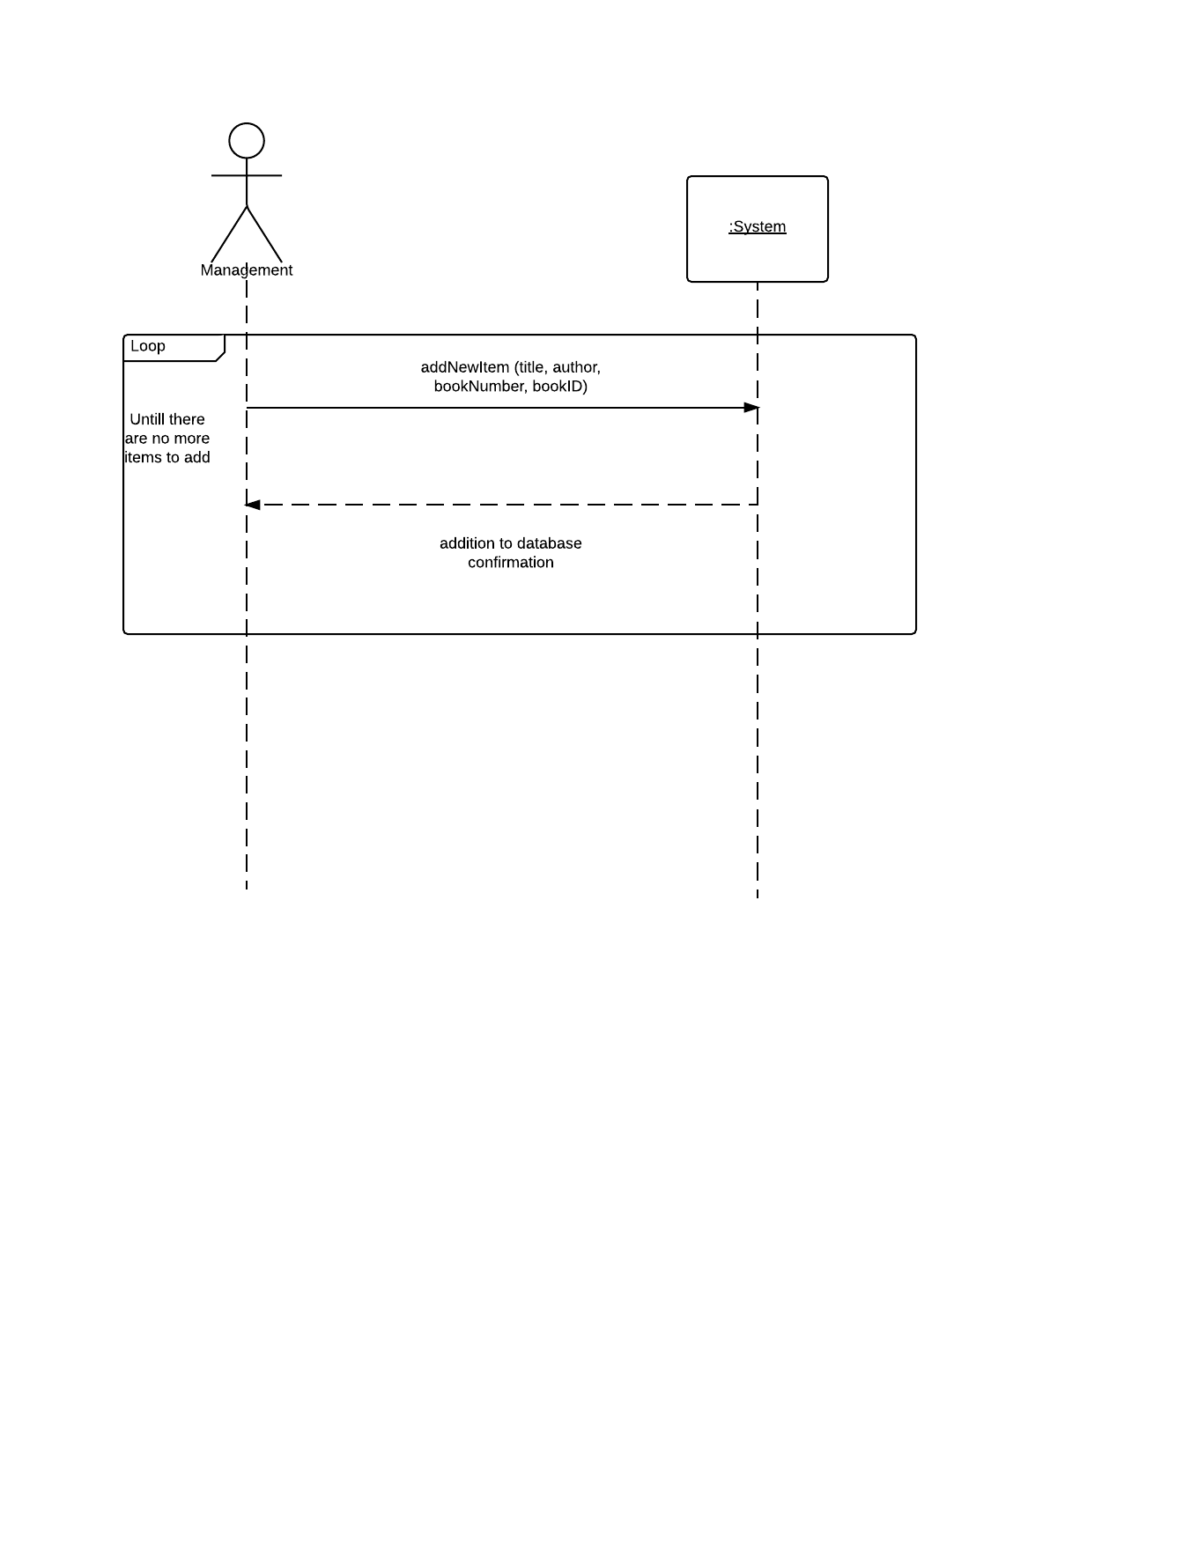

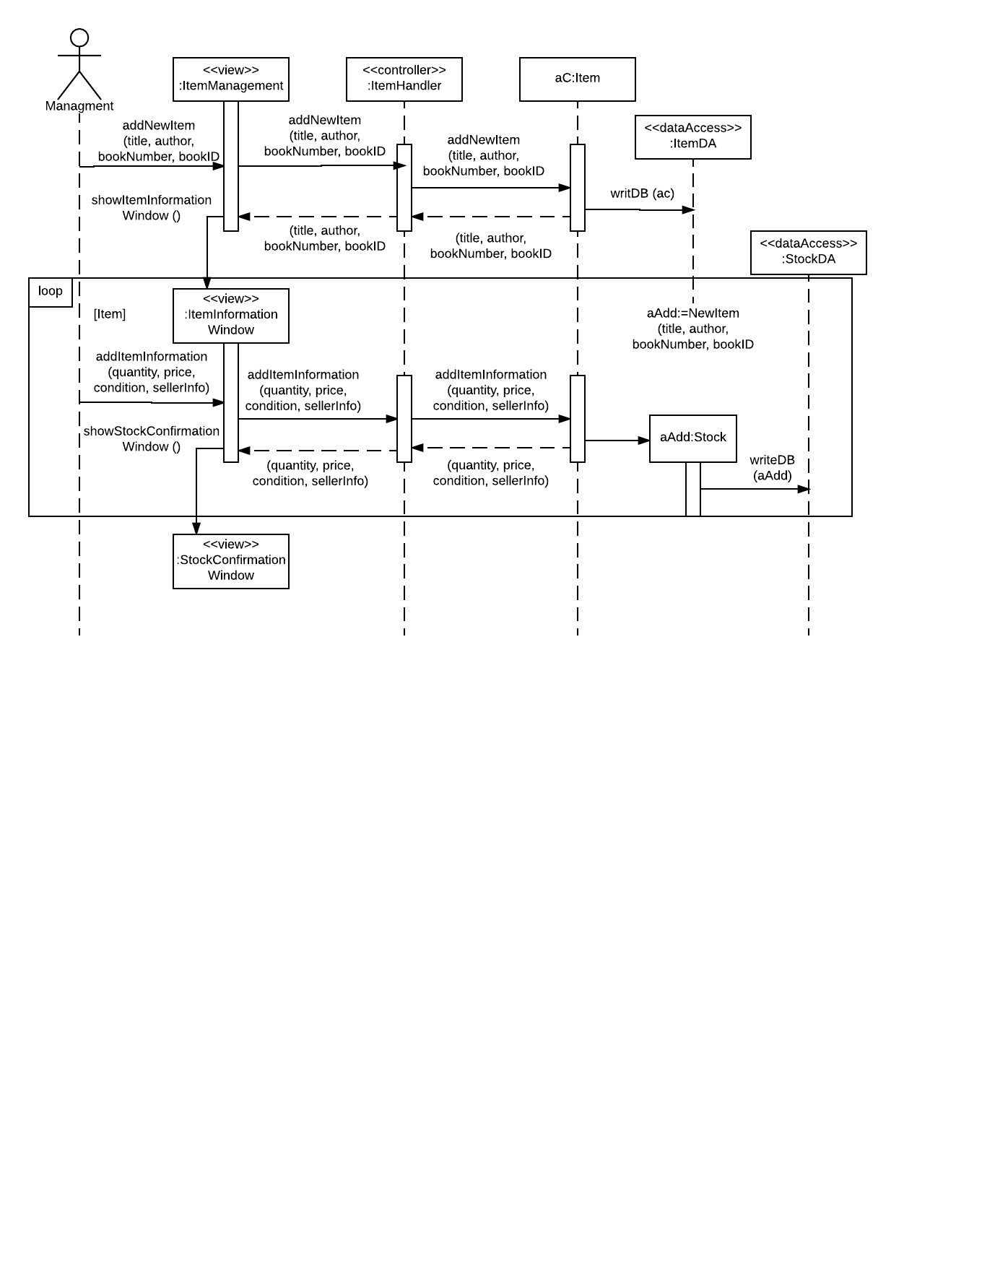

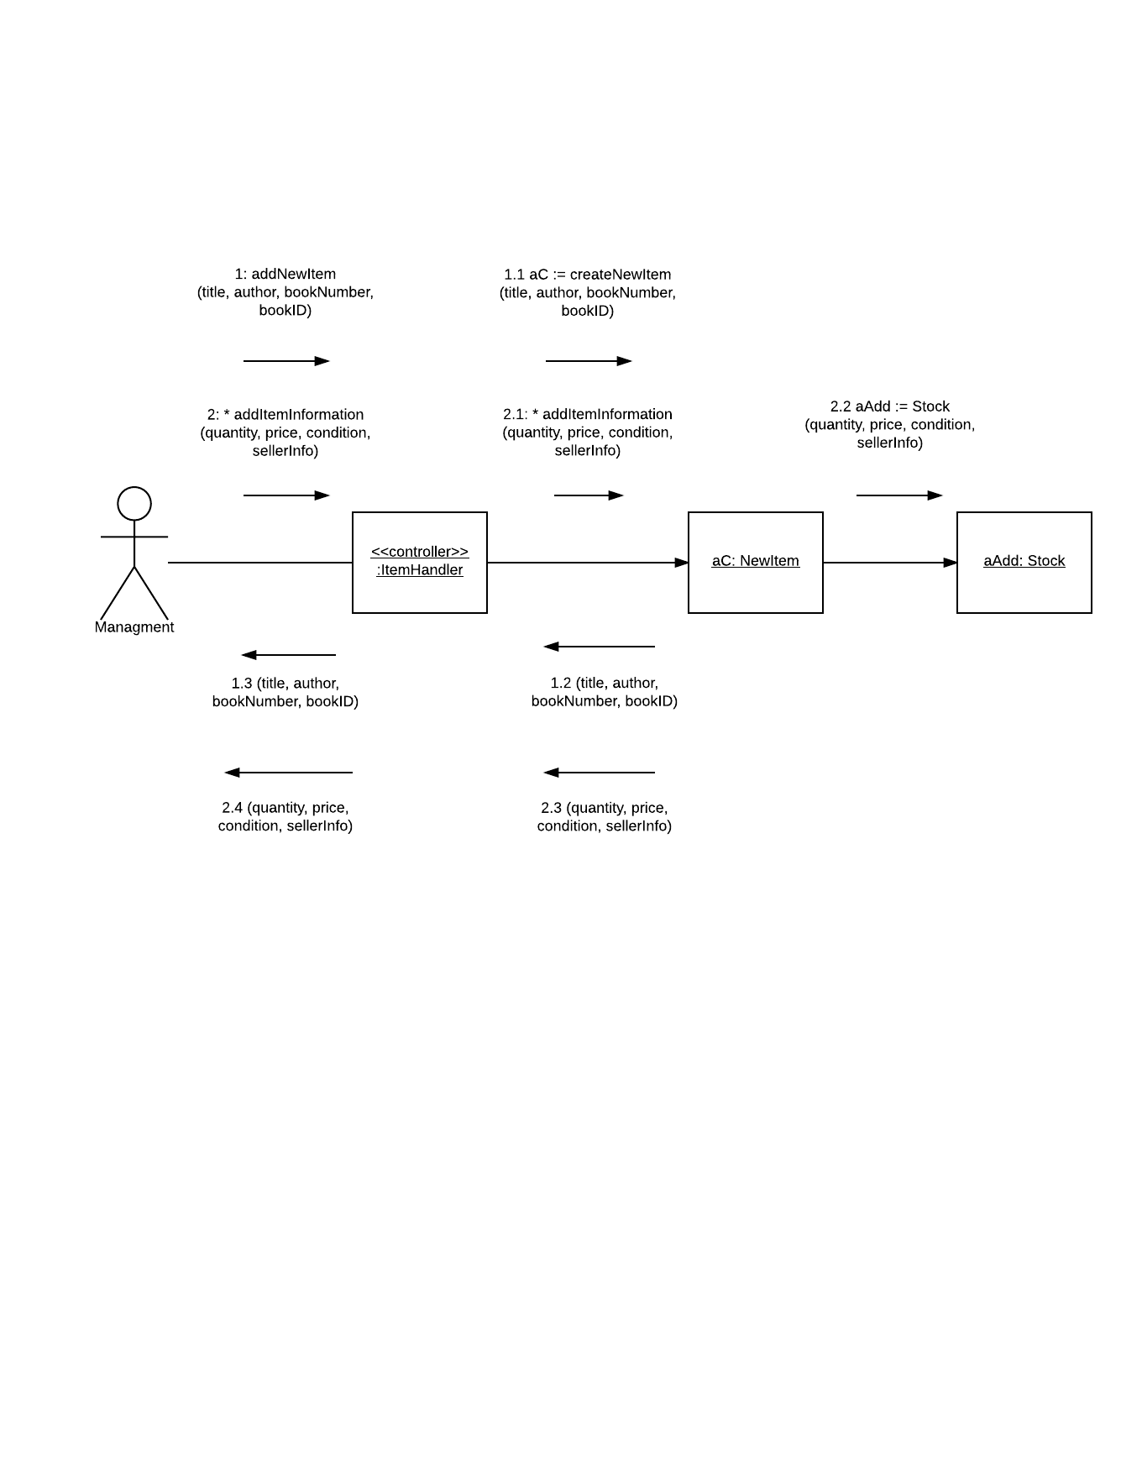

Addendum

For use case add/update product information we ran into the same issues as the previous use cases. A poor system sequence diagram halted a lot of the progress that could have been easily avoided. The diagram was very poorly done and contained almost no useful information. We had to create all the messages and data while we were already trying to design things. Given another iteration we would have definitely redone this section.

# Fully Developed use case #10

|  |  |  |
| --- | --- | --- |
| Use Case Name: | Add promotion. | |
| Scenario: | A Sales promotion needs to be added | |
| Triggering event: | A new sales promotion needs to be applied to an existing in the database. | |
| Brief description: | A new sales promotion needs to applied to an item already existing on the sales website. A marketing representative needs to add the discounted price to the online store. | |
| Actors: | Marketing Representative | |
| Related use cases: | Might be invoked by the search item use case. | |
| Stakeholders: | Customer, Marketing Representative, Sales department. | |
| Preconditions: | Item must already exist on the database and online store.  Marketing representative needs to be logged into the item database system. | |
| Postconditions: | Item will be updated on the database and online website with the discounted price from the sales promotion. | |
| Flow of activities: | Actor | System |
| 1. Marketing representative wishes to add a promotion to one or more products on the online store. 2. Marketing representative enters the item they wish to add the promotion.   3. Marketing representative enters the sales promotion. | 1.1 System connects to the item database.  1.2 System asks what item the marketing representative wishes to apply the promotion to.  2.1 System verifies the item that the discount needs to be applied to.  2.2 System prompts the representative on what the sales promotion should be.  3.1 System verifies that the sales promotion enter is valid.  3.2 System adds promotion to specified item.  3.3 System updates website so that it will reflect promotion price. |
| Exception conditions: | 1.1 System cannot connect to database.  1.2 Marketing representative enters an invalid item.  2.1 Invalid discount is trying to applied.  3.1 Invalid sales promotion is entered.  3.2 system adds promotion incorrectly to item.  3.3 System updates website incorrectly. | |

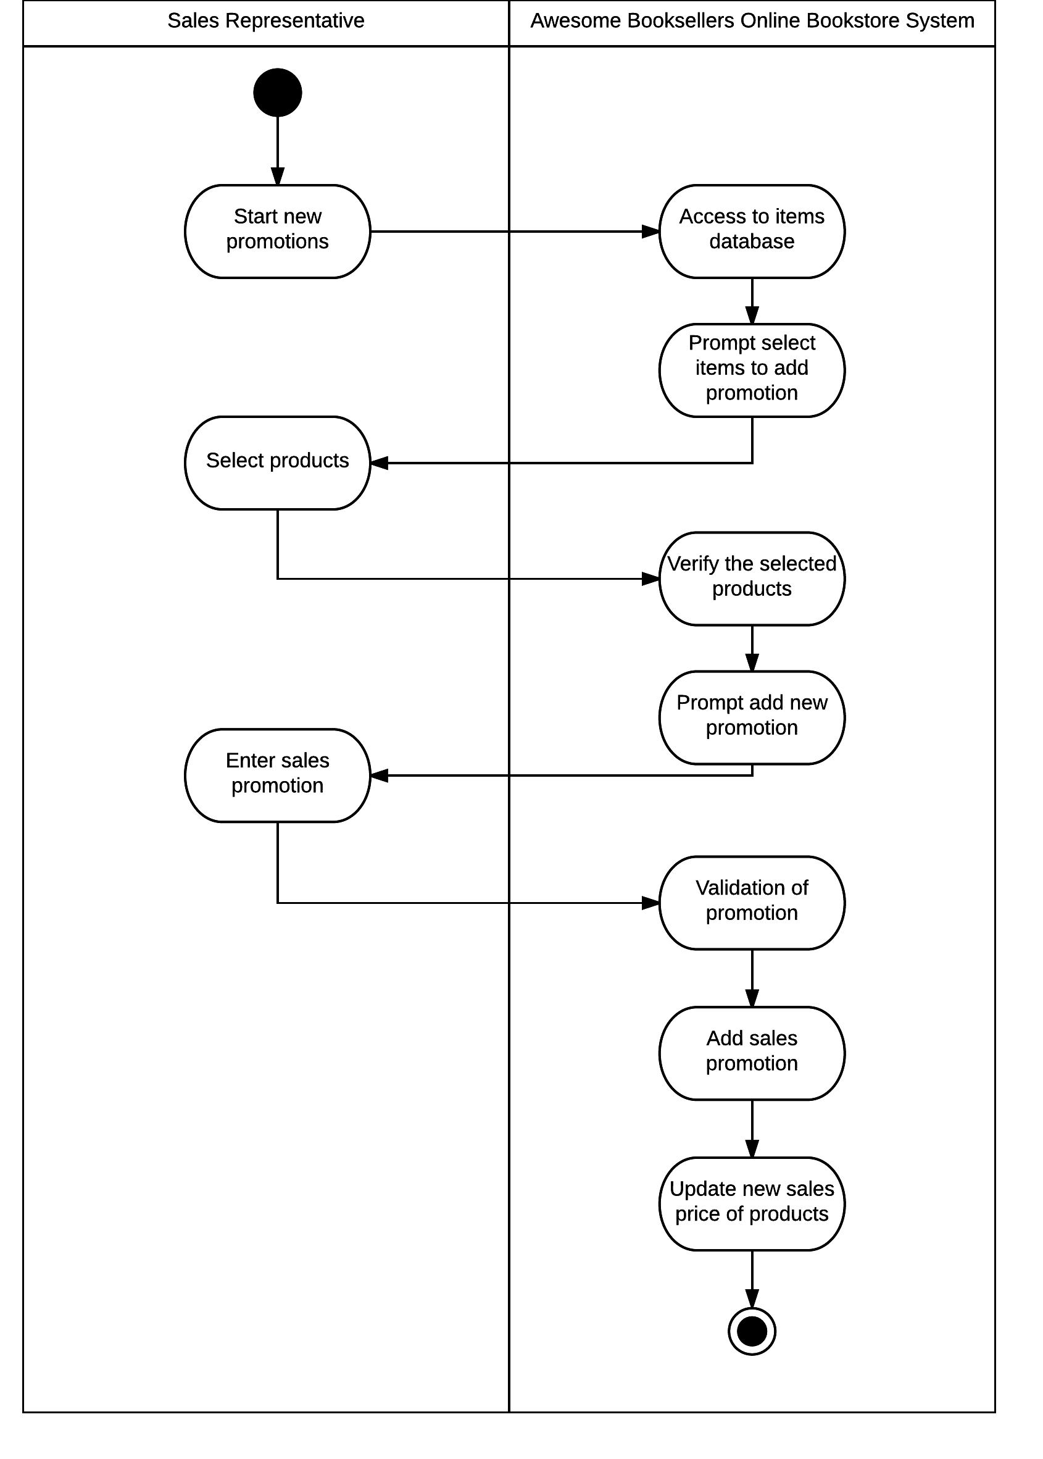

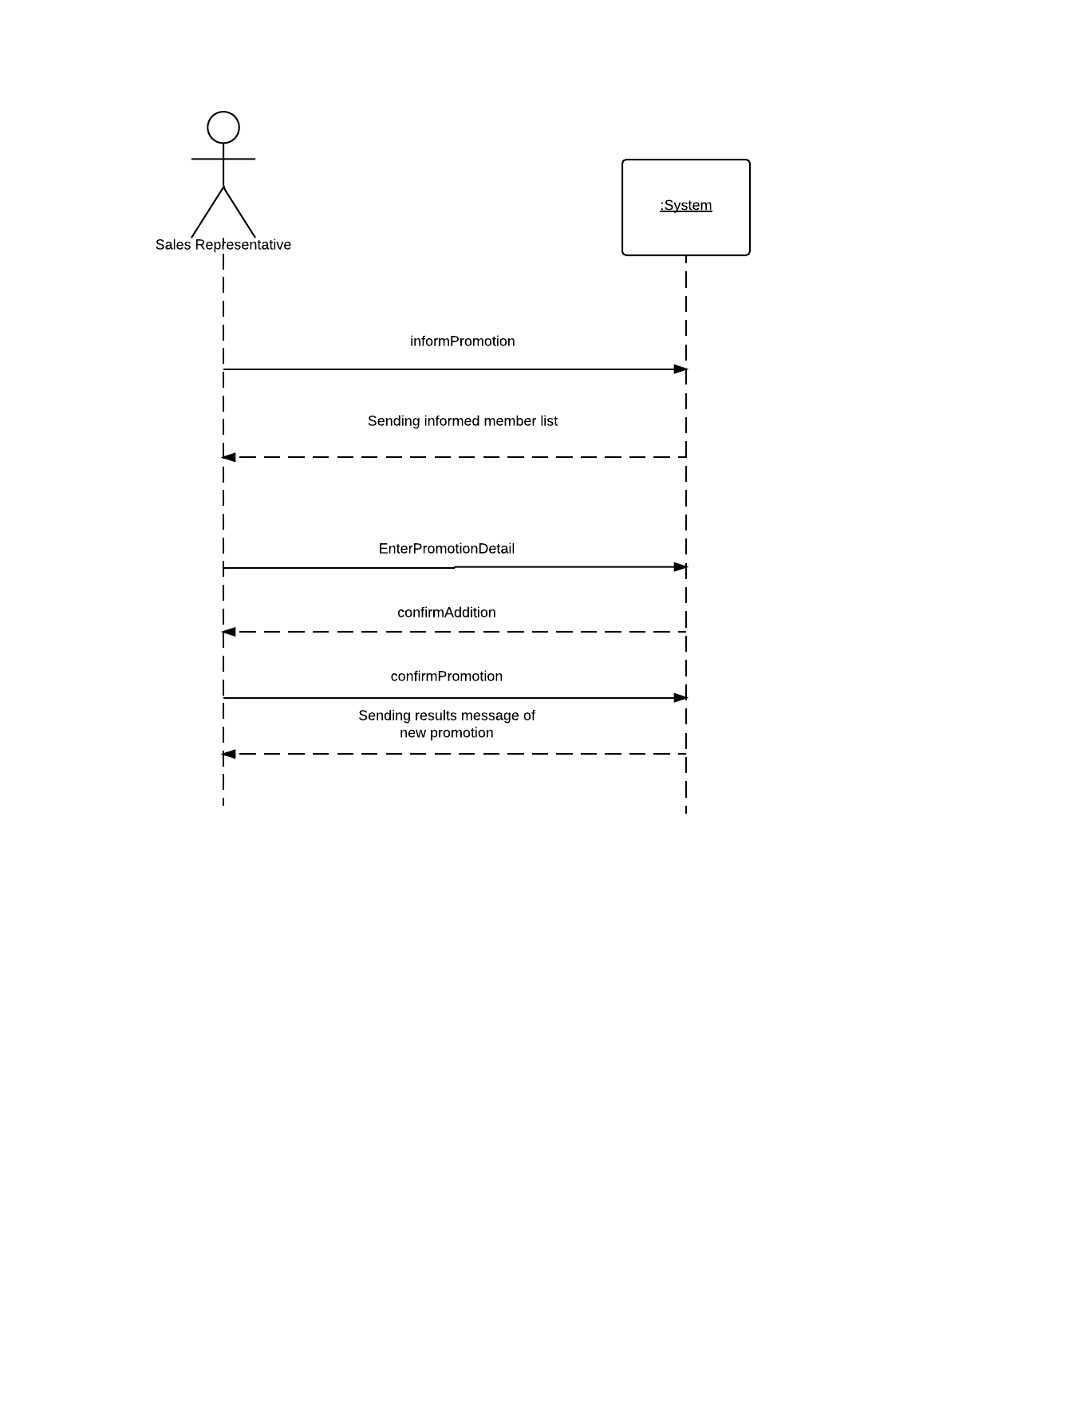

**Fully Developed use case #11**

|  |  |  |
| --- | --- | --- |
| Use Case Name: | Request return. | |
| Scenario: | Item needs to be returned to the store. | |
| Triggering event: | Customer needs to return an item they no longer want. | |
| Brief description: | Customer needs to return an item to the seller that is no longer wish to have or that is damaged. | |
| Actors: | Customer, Sales, Warehouse | |
| Related use cases: | none | |
| Stakeholders: | Customer, Sales, Warehouse | |
| Preconditions: | Customer must have purchased item already.  Item must have been shipped to customer already. | |
| Postconditions: | Item will be returned to the warehouse.  Customer will be refunded money for purchased item. | |
| Flow of activities: | Actor | System |
| 1. Customer wishes to return item they purchased. 2. Customer answers reason of return survey. 3. Customer fills out the return form. 4. Customer returns products. | 1.1 System surveys why customer wants to return item(s).  2.1 System stores the survey.  2.2 System prompts a new return form.  3.1 System stores the return form.  3.2 System creates label for items returned and emails it to the customer.  3.3 When product is received return label is scanned into the system.  3.4 System finds return case and marks as completed.  3.4 System adds the items back to the inventory database.  3.5 System refunds customer their money. |
| Exception conditions: | 1.1 System cannot connect create reason of return survey.  2.2 New return form cannot found.  3.2 System creates an incorrect return label.  3.3 Product barcode cannot be read and must be entered manually.  3.4 System does not add the item back to the correct inventory.  3.5 System fails to refund the customer. | |

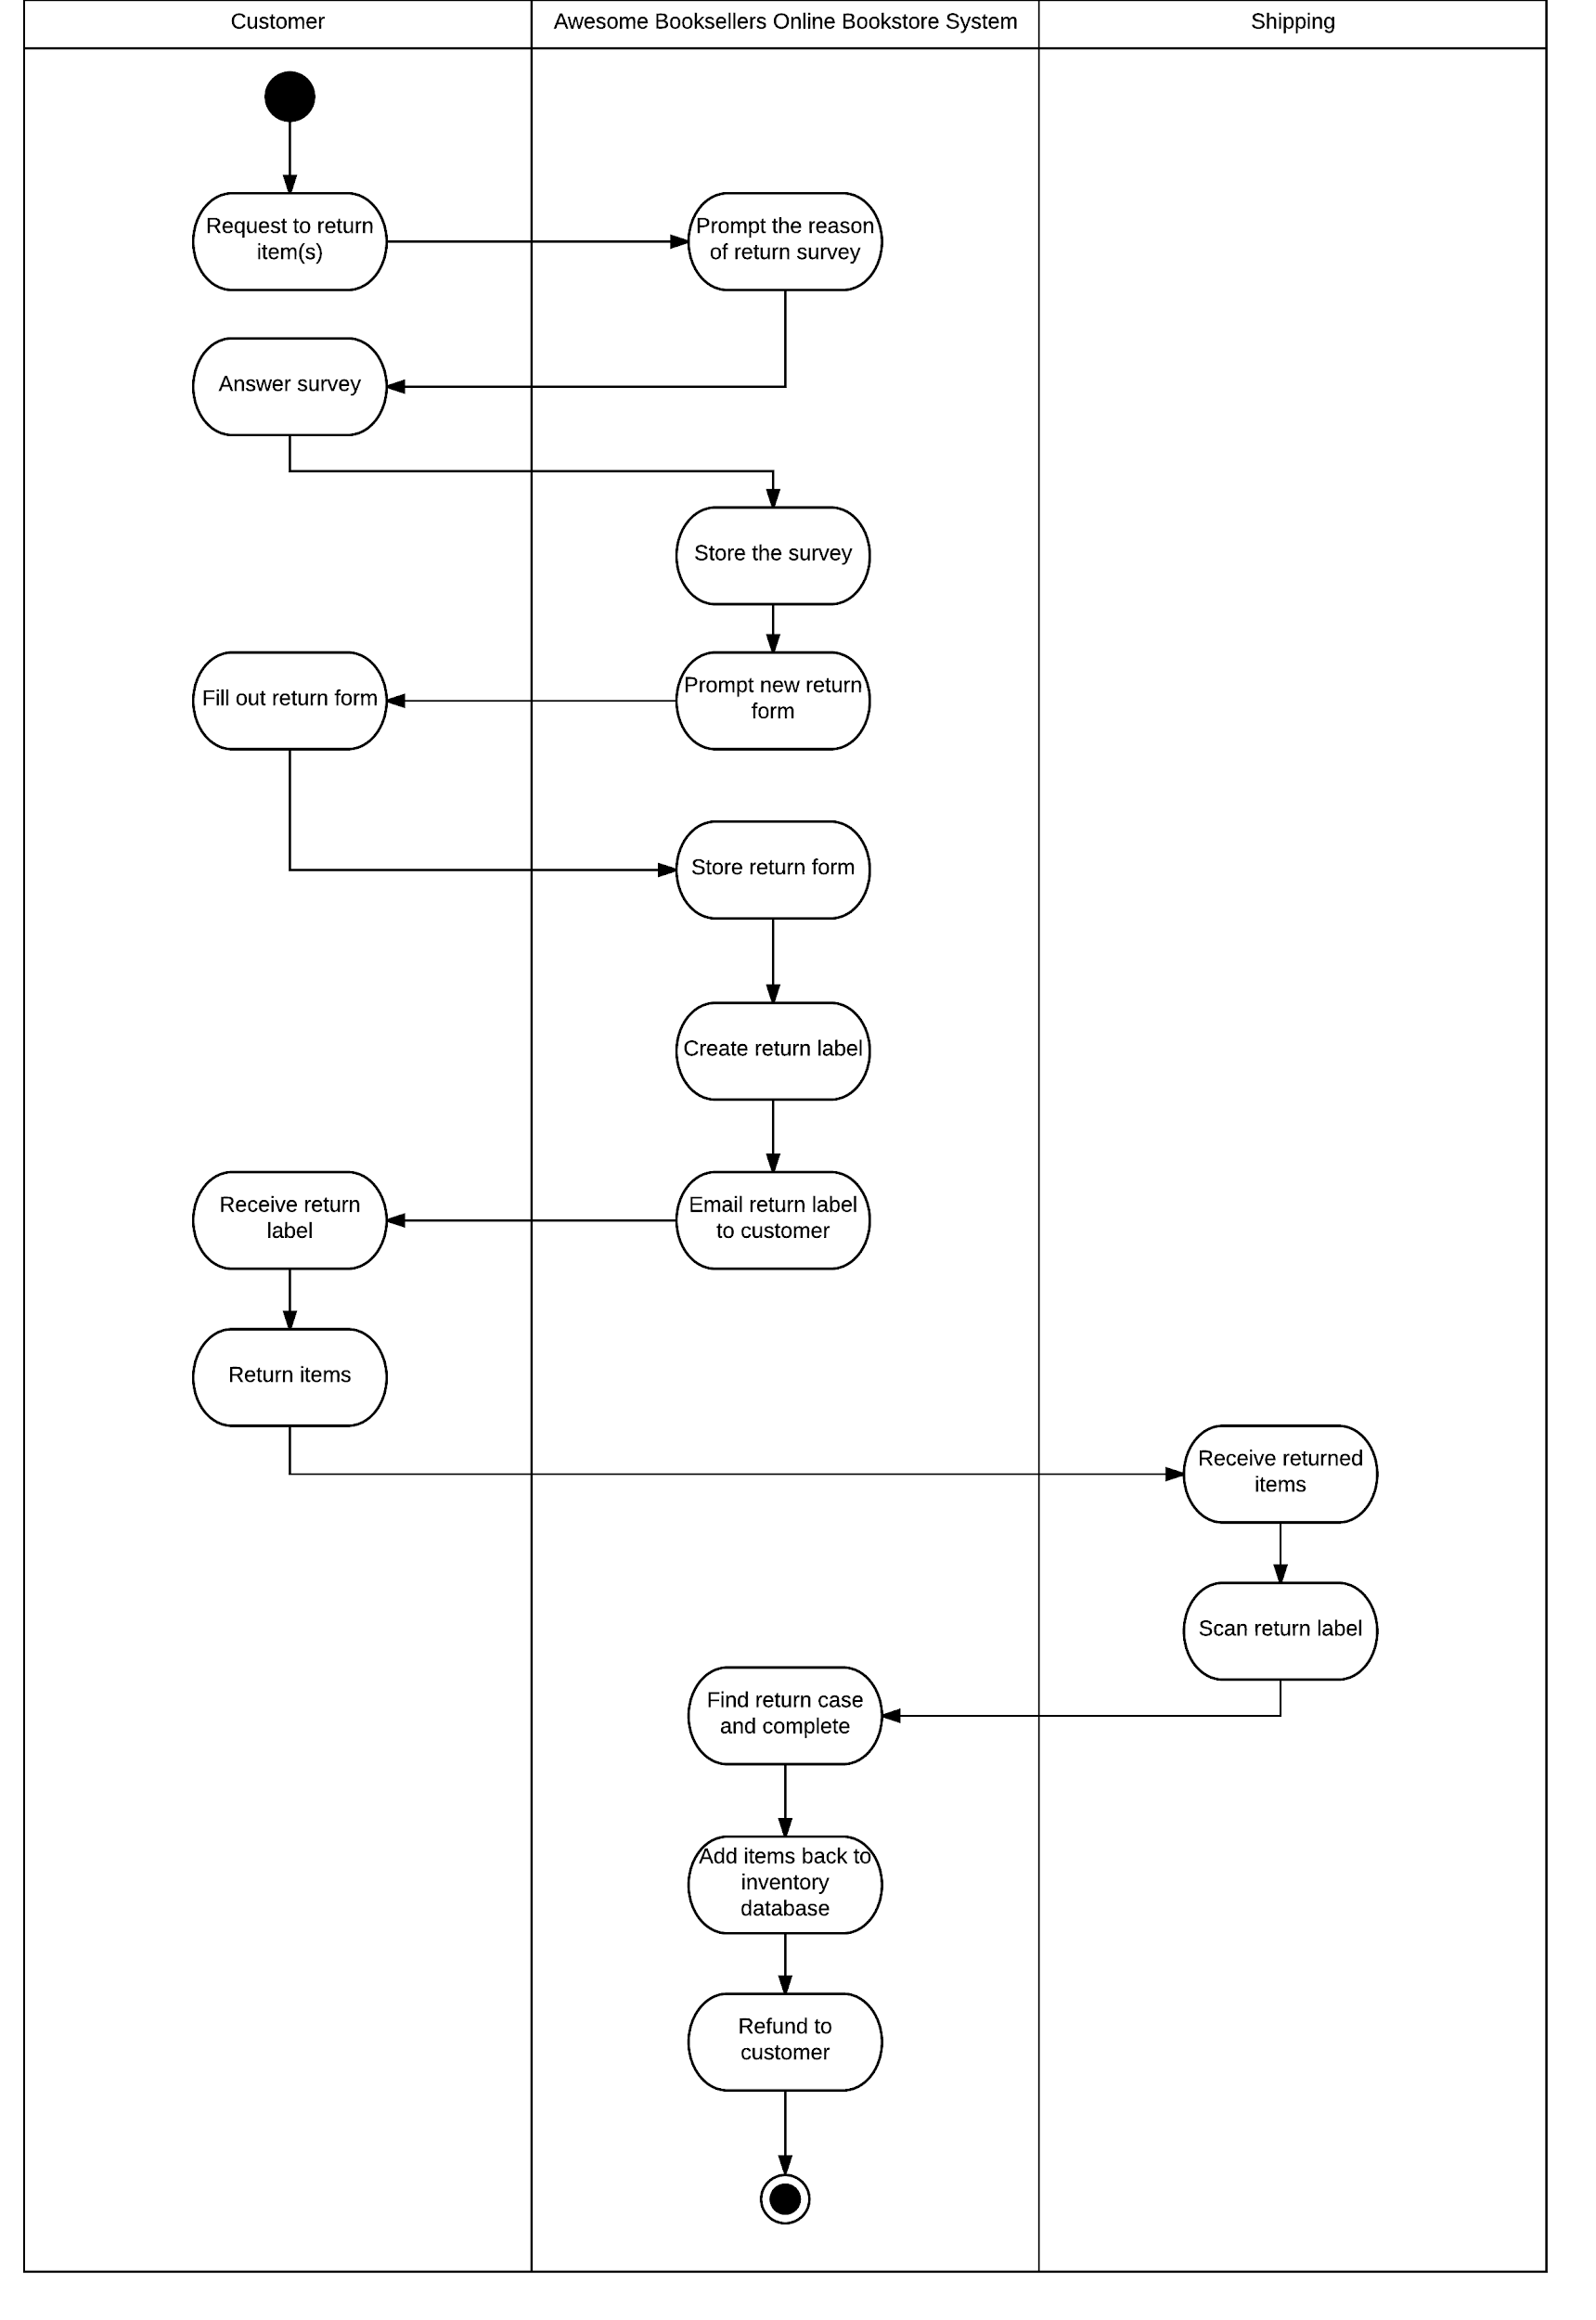

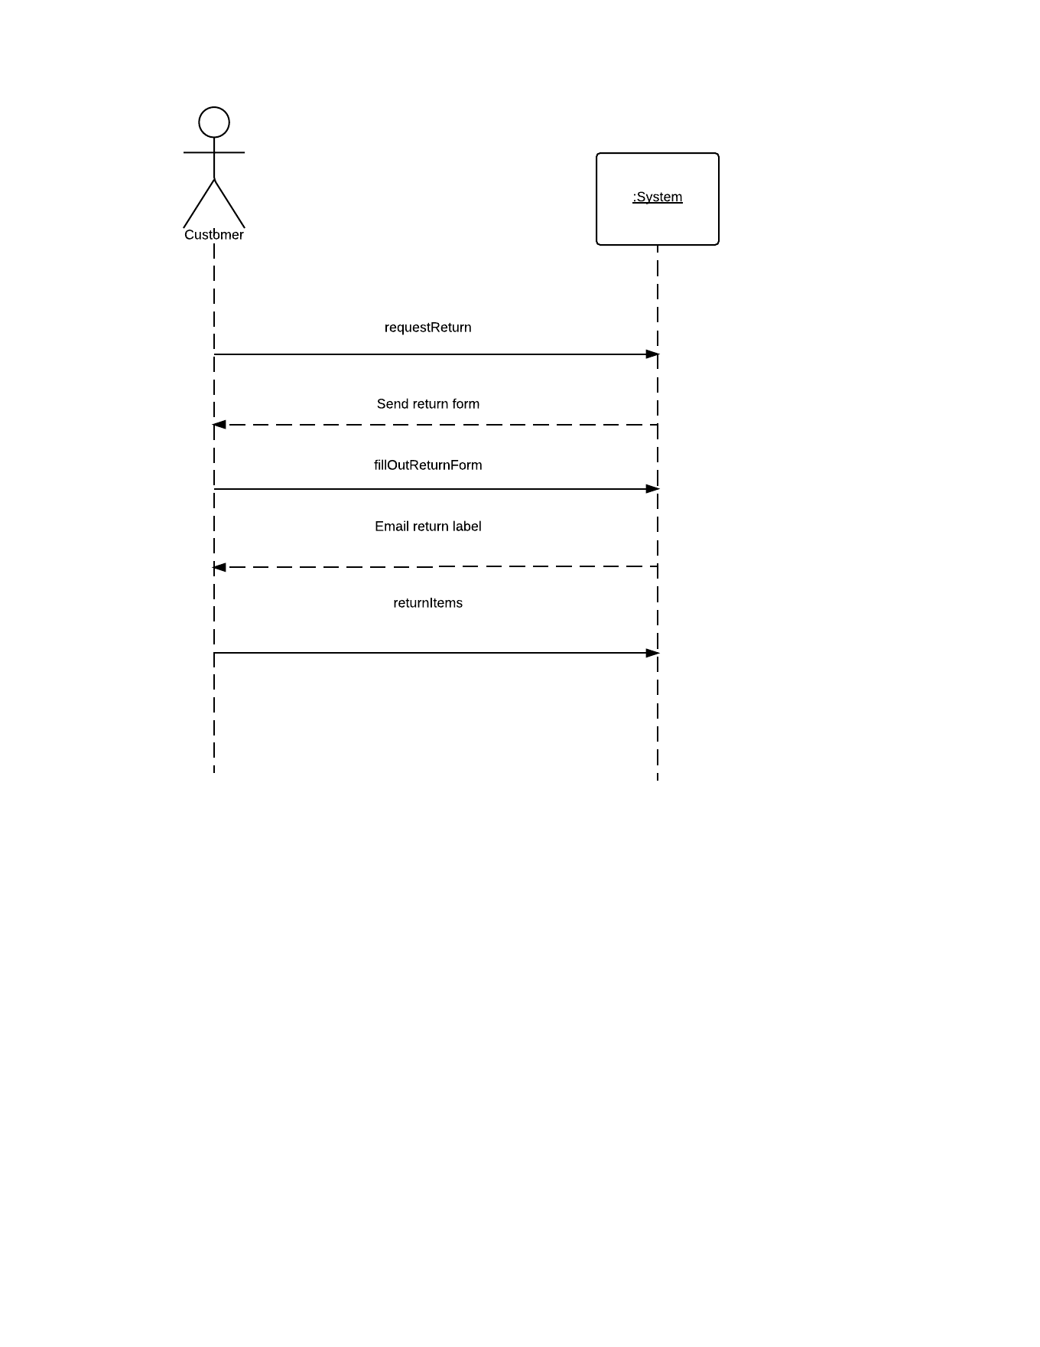

# 

# 

# 

# 

# 

# 

# 

# 

# -Blank ERD & Data Flow - Page 1 (3).png

# 

**Addendum**

# The use case 11 “Request Return”

# Fully Developed use case #12

|  |  |  |
| --- | --- | --- |
| Use Case Name: | Produce daily transaction summary report. | |
| Scenario: | Transaction report is created. | |
| Triggering event: | Management would like to look at a sales report. | |
| Brief description: | Management needs to print out a transaction summary report for their records. They connect to the system so that they can print this out. | |
| Actors: | Management. | |
| Related use cases: | none. | |
| Stakeholders: | Management. | |
| Preconditions: | There must be transactions recorded on the database. | |
| Postconditions: | Manager will have a printed record of all the transactions. | |
| Flow of activities: | Actor | System |
| 1. Manager would like to print out Transaction summary. | 1.1 System connects to transaction database.  1.2 System compiles all the transactions into a report.  1.3 System prints out transactions report. |
| Exception conditions: | 1.1 System cannot connect to transaction database.  1.2 System fails to compile reports.  1.3 Printer jams or cannot connect over the network so report cannot be printed. | |

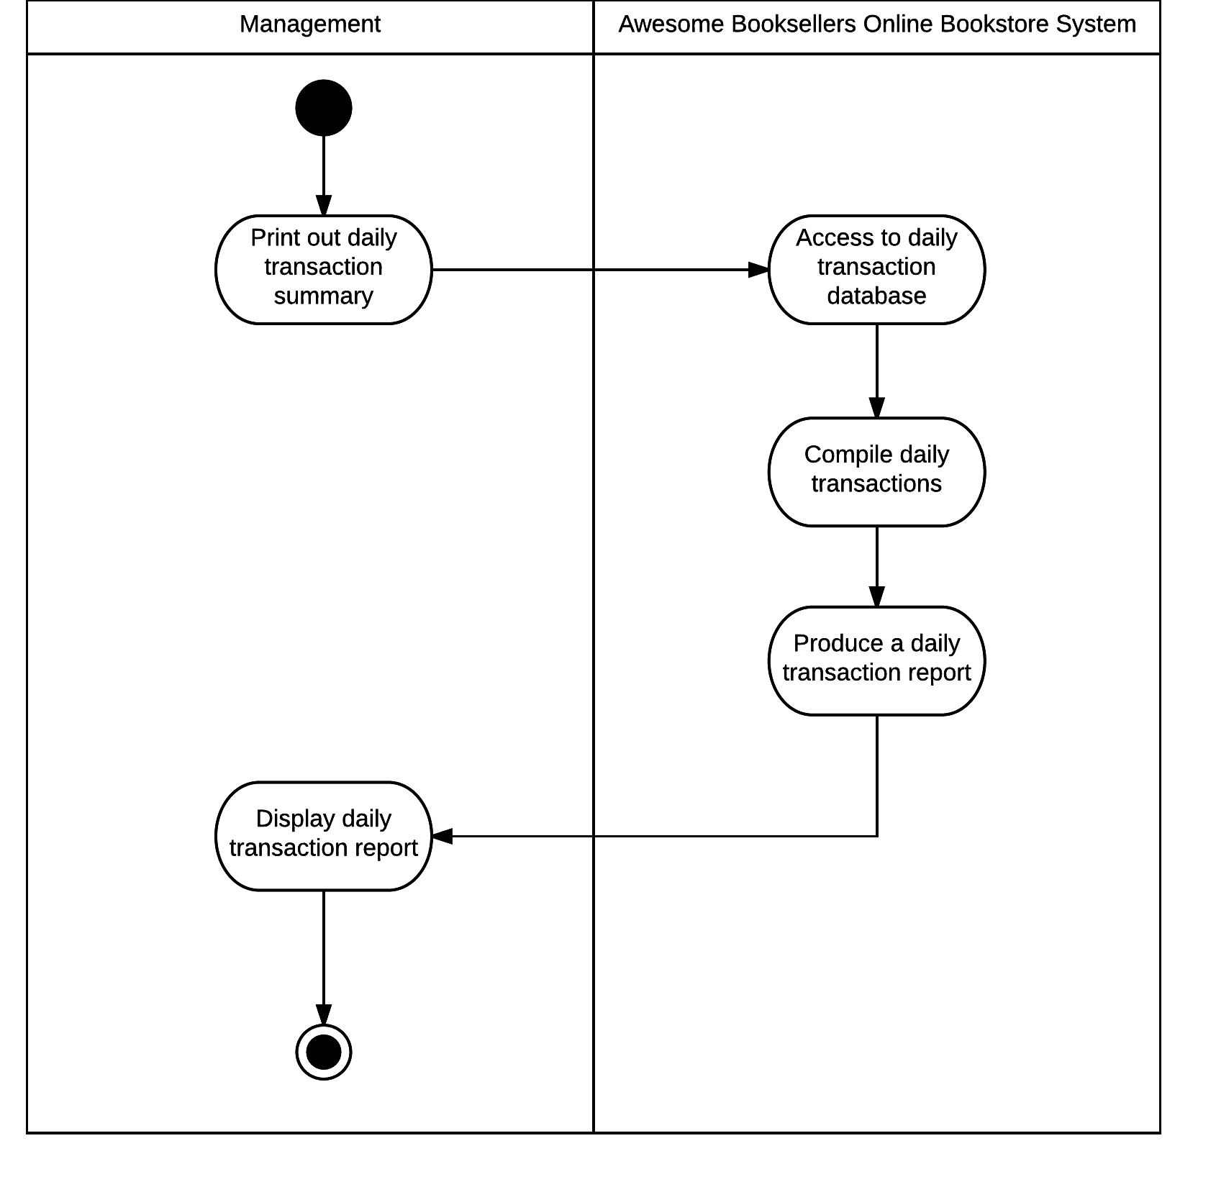

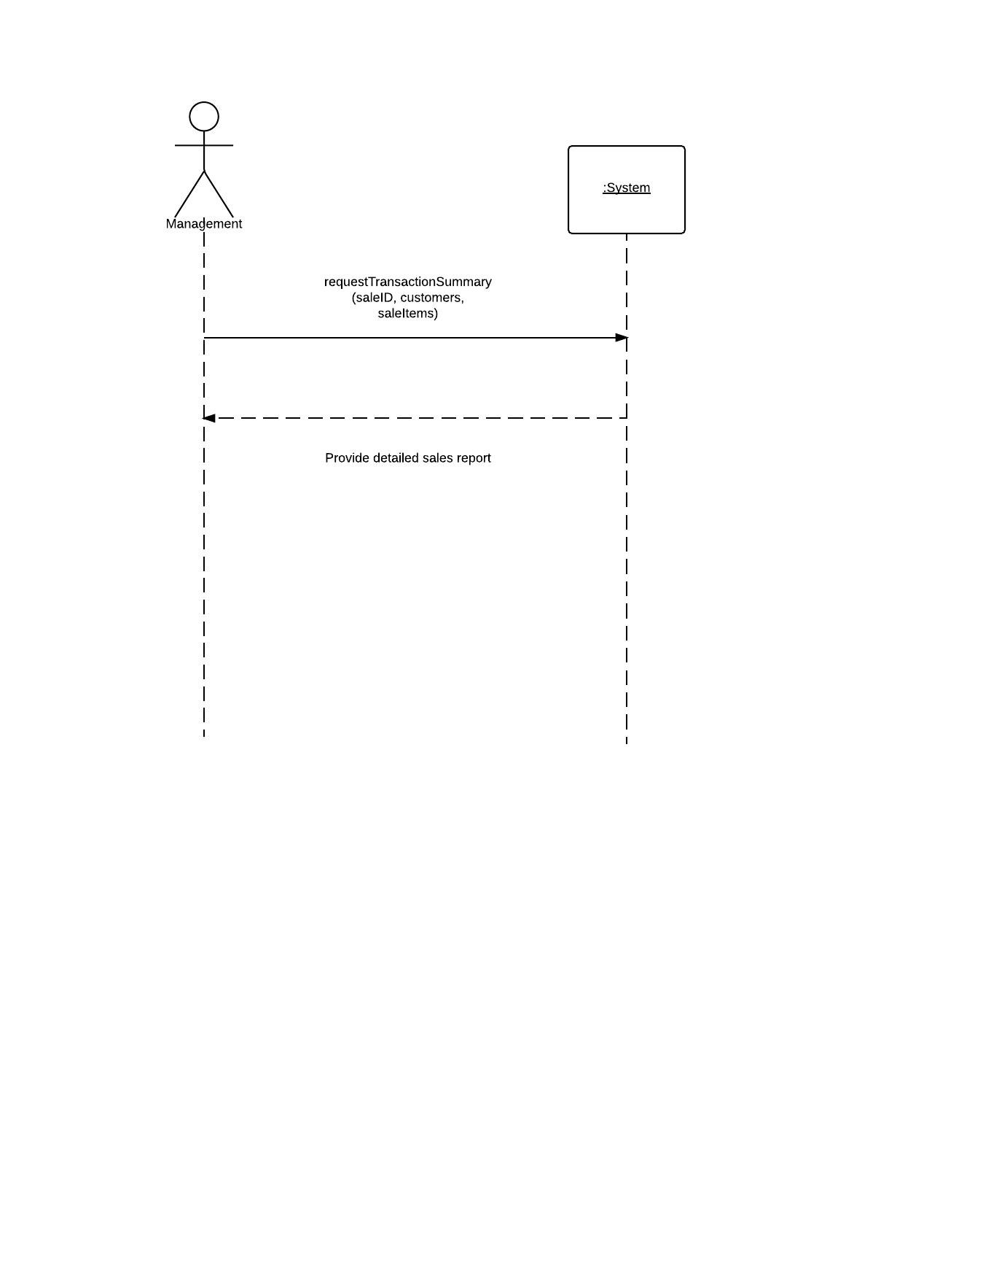

# 

# 

# 

# 

# 

# 

# 

# 

# 

# 

# 

# 

# 

# 

# 

# 

# 

# 

# 

# 

# 

# 

# 

# 

# 

# 

# 

# 

# 

# 

# 

# 

# 

# 

# 

# Project Log

* Created outline of project with corresponding pages in the book to the specific things needing to be created.
* Created System vision document.
* Created a list of use cases.
* Started developing use cases.
* Finished developing use cases and starting making activity diagrams for each one. During the creation we assumed that the company would be able to transition from phone sales to web sales with minimal logistical problems.
* Made Employee survey. The survey is based off it being sent to 55 Sales reps, 30 Customer Service reps, and 15 Marketers. (100 total) We are also assuming that every single one of them answered.
* Created Domain Model Class Diagram.
* Developed feasibility issues.
* Developed project estimates.
* Developed Risk Matrix.0
* Completed SSD for all 12 fully developed use cases.
* Table of contents.
* Final editing and formating.